A RITUAL ADS WHITE PAPER
The Cinematic Intelligence Studio
What Comes After the Agency and the Production Company

Jethro Rothe-Kushel
Founder and Chief Executive Officer, Ritual Ads, Inc.
September 2026
A tool generates. An intelligence knows. A studio answers for the result.
Ritual Ads is a cinematic intelligence studio, powered by Ritual Engine.

Executive Summary
For seventy years, commercial creative was made by two kinds of institution. Agencies had the idea. Production companies made the film. A brand hired both, paid for the handoffs between them, and kept whatever was learned in the memories of the people who happened to be in the room. That arrangement is coming apart at both ends. Holding companies are retiring agency brands that built the modern industry, the largest post-production houses have closed, and commercial shoot days in Los Angeles have fallen 35 percent below their five-year average.¹²³ Meanwhile a third institution, the AI tool vendor, has arrived with the capacity to generate and no capacity to know.
This paper defines what replaces them. A Cinematic Intelligence Studio is an institution that makes cinematic commercial creative through a persistent, governed intelligence rather than through conventional production alone. It combines three things that have never lived in one place: the craft of moving images, a brand-specific intelligence that holds identity, approval history, and performance learning, and an operating model that carries a campaign from brief to performance under one accountable roof. Cinematic names the craft. Intelligence names what the studio knows. Studio names the institution that makes, governs, and repeats.
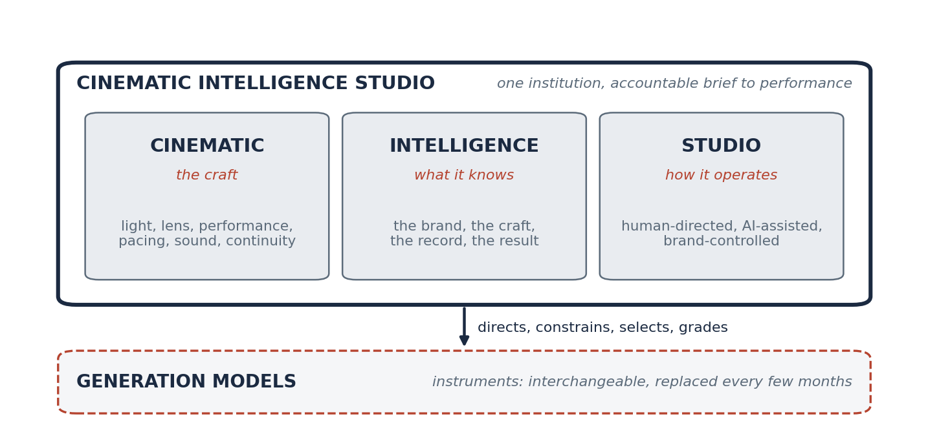
Figure A. The Cinematic Intelligence Studio in one view. Craft in motion, a brand-specific intelligence, and a governed operating model, held together in one institution that treats generation models as instruments.
The case rests on three findings. Craft is the largest lever in advertising and the least measured: creative quality accounts for nearly half of media impact,⁴ emotional work delivers twice the profit of rational work,⁵ and audiences reward seamless AI and punish obvious AI.⁶ Intelligence is what the industry's tools lack: the vendors who use the term define it as measurement, which is necessary and leaves the craft gap open.⁷ And the studio form is the one the film industry itself is choosing: Lionsgate moved from licensing a model in 2024 to owning equity in the model company in 2026, Netflix put generative footage on screen, and Disney's billion-dollar license of its characters to a single vendor's product lasted three months before that product was discontinued.⁸⁹¹⁰¹¹ The studio that holds the intelligence endures. The model is an instrument. Generation is commoditizing. Enterprise creative operations are not. The Cinematic Intelligence Studio is the institution built for the second fact.
Contents

1. The Problem: The Institutions Are Coming Apart
Every industry is organized around its scarcest input. For most of advertising's history that input was production. Film was expensive to make, so the institutions that made it were built around scarcity: agencies to ration ideas, production companies to ration craft, post houses to ration finishing, and a handoff at every boundary. The 4A's last published survey of national commercial costs put the average 30-second spot at $324,000 in 2010, and no comparable survey has been published since.¹² The number was the point. When a frame cost that much, the institution that could deliver it held the value.
That world is ending on both sides at once. On the demand side, content has become abundant in a way the old institutions cannot serve. Adobe's 2025 survey of more than 1,600 marketers found that 62 percent had already seen demand for content rise five times in two years, and 71 percent expected it to grow more than five times again by 2027.¹³ No agency and no production company was built to produce at that rate. On the supply side, generative models have made moving images nearly free to produce, which strips the scarcity out of the thing the production company sold.
The institutions are responding by dissolving. Omnicom closed its acquisition of Interpublic in November 2025, creating a company with more than $25 billion in revenue,¹⁴ and within a week announced 4,000 redundancies and the retirement of DDB, FCB, and MullenLowe as global networks.¹ DDB was the agency whose founder, Bill Bernbach, created the modern creative agency with Volkswagen in 1959.¹⁵ WPP's shares fell 18 percent to a 27-year low on its new chief executive's first profit warning,¹⁶ its market value fell from £24 billion in 2017 to £3.1 billion, and it left the FTSE 100.¹⁷ Its 2026 strategy abandons the holding-company structure altogether in favor of a single company built around an AI platform.¹⁸ Forrester predicts 15 percent of agency jobs will be eliminated in 2026, following roughly 8 percent in 2025, and describes agencies as pivoting "from selling services to selling solutions."¹⁹
Production is contracting in step. Technicolor shut down The Mill and MPC in February 2025, affecting roughly 10,000 jobs worldwide.² Commercial shoot days in Los Angeles fell to 2,742 in 2025, down 14.5 percent in a year and 35.3 percent below the five-year average.³
Every industry is organized around its scarcest input. Advertising was organized around production. Production is no longer scarce.
Brands have noticed. Eighty-two percent of ANA members now operate an in-house agency, up from 42 percent in 2008,²⁰ and by 2026 the primary reason had changed. Cost savings fell from the top-cited benefit to a footnote, and 53 percent of members described the in-house agency's primary role as a strategic partner in upstream brand-building work.²¹²² The brand is pulling the idea inside. What it cannot pull inside is the craft of cinema and the intelligence to govern a thousand variants of it, and Forrester's own data shows the gap: 61 percent of agencies use generative AI in marketing, against 17 percent of in-house agencies.²³
Three institutions, each holding one piece. The agency holds the idea and is consolidating. The production company holds the craft and is contracting. The tool vendor holds the generator and knows nothing about any brand. Nobody holds the whole. That is the gap the Cinematic Intelligence Studio fills.

2. Three Words
The name is the definition. Each word replaces a piece of the old arrangement, and each names a capacity the others never had.
Word | What it names | What it replaces
Cinematic | The craft of moving images: light, lens, performance, pacing, sound, continuity | The production company's monopoly on craft
Intelligence | A persistent, brand-specific memory of identity, approvals, and performance | The agency's institutional memory, which lived in people
Studio | One accountable institution from brief to performance, governing generation models as instruments | The handoffs between agency, production, post, and tool

Cinematic. The word is chosen against "content" and against "creative." Content is anything that fills a slot. Creative is anything an agency ships. Cinematic is a discipline with a grammar, a history, and a measurable effect on audiences, and it is the hardest form of brand expression to do well. Section 4 argues that it is also the most valuable.
Intelligence. The word is chosen against "AI" and against "tools." A tool generates. An intelligence knows: what this brand looks and sounds like, what was approved and refused, what worked and why. Section 5 argues that this knowledge is the scarce asset, and that it has to live inside the institution that makes the work.
Studio. The word is chosen against "agency," "vendor," and "platform." An agency represents a client to suppliers. A vendor sells a product. A platform hosts other people's work. A studio makes the work, owns the means of making it, and answers for the result. Section 6 argues that the studio form, revised for a world of abundant generation, is the institution that survives.
A tool generates. An intelligence knows. A studio answers for the result.

3. What a Cinematic Intelligence Studio Is

Definition
A Cinematic Intelligence Studio (CIS) is an institution that produces cinematic commercial creative through a persistent, governed intelligence rather than through conventional production alone. It holds three capacities in one place: the craft of moving images, a brand-specific intelligence that encodes identity, cinematic grammar, approval history, and performance learning, and an operating model that carries a campaign from brief through generation, approval, and distribution to measured results under one accountable roof. It treats generation models as interchangeable instruments. It is human-directed at every decision that matters, AI-assisted at every step where assistance is possible, and brand-controlled by design.

What it is not
A Cinematic Intelligence Studio is not a production company with AI tools bolted on. A production company delivers a film and leaves; it holds no memory of the brand across campaigns and no accountability for what the film did in market. It is not an agency. An agency holds the idea and the relationship and outsources both the craft and the measurement. It is not an AI video vendor. A vendor sells a generator that knows nothing about any particular brand and is replaced every few months. It is not an in-house team, which holds the brand's knowledge in people and rarely holds the craft. And it is not a content farm, which optimizes for volume and is the thing this paper argues against.
Capacity | Agency | Production company | AI tool vendor | In-house team | Cinematic Intelligence Studio
Makes cinematic work | Outsources | Yes | Generates | Rarely | Yes
Holds brand intelligence | In people | No | No | In people | In a persistent system
Governs approval and lineage | Partly | No | No | Partly | By design
Learns from performance | Reports | No | No | Sometimes | Writes it back
Independent of any one model | Not applicable | Not applicable | No | Depends | Yes
Accountable brief to performance | For the idea | For the film | For the output | For everything, alone | For the whole

The studio and the Large Brand Model
The intelligence at the center of a Cinematic Intelligence Studio is a Large Brand Model: a persistent, model-agnostic intelligence that encodes a single brand's identity, cinematic grammar, governance history, and performance record, and uses that encoding to direct, constrain, and evaluate any generation model producing creative on the brand's behalf. The Large Brand Model is the architecture. The studio is the institution that runs it. One without the other is incomplete. A model without a studio has no craft to direct and no workflow to sit inside. A studio without a model is a production company with better software.
A model without a studio has no craft to direct. A studio without a model is a production company with better software.

4. Cinematic: The Craft That Carries the Value
Film is a language. The standard text on the subject has opened with that claim since 1979: film is "an art form with a language and an aesthetic all its own," and the creative choices filmmakers make determine "what viewers experience and how they respond."²⁴ The language has rules that were learned expensively. The frame rate was fixed at 24 frames per second in 1927 to carry synchronized sound.²⁵ The wide frame arrived with CinemaScope in 1953, an anamorphic lens squeezing a wide image onto standard film and unsqueezing it in projection.²⁶ Continuity editing, the technique of "removing moments of redundancy in a moving image while still presenting the illusion of the continuous passing of time," is the grammar that lets an audience follow a story without noticing the cuts.²⁷ The American Society of Cinematographers, founded in 1919, describes its purpose as advancing the art "through artistry and technological progress."²⁸ Craft and technology have always been the same discipline.
The craft has one principle above the others, and Roger Deakins states it plainly: "The imagery and the photography and the effects really are there to serve a story," and "there's nothing worse than an ostentatious shot" that pulls the viewer out of the characters.²⁹ That principle is the difference between a scene that belongs to a brand and a scene that merely contains its logo, and it is the thing that generation models, left to themselves, do not know.

Why it is the most valuable form
The evidence that craft drives business results is deep and predates AI by decades. Binet and Field's analysis of the IPA Effectiveness Databank found that emotional advertising is twice as efficient as rational advertising and delivers twice the profit.⁵ Their 2018 follow-up found the finding holds even in rational, high-research categories, which are "often those most in need of an injection of emotion."³⁰ Kantar's cross-media database finds that creative quality contributes nearly 50 percent of media impact, far more than reach or frequency.⁴ Nielsen Catalina's analysis of roughly 500 campaigns put creative's share of sales lift at 49 percent.³¹ System1's validation against the IPA databank found that a five-star ad achieves, on average, three points of market share gain for the same share of voice that earns a two-star ad half a point, and that five-star ads are four percent of all ads tested.³²
The craft has also been eroding. Orlando Wood's analysis of thirty years of television advertising, published by the IPA as "Lemon," found that the right-brain features of advertising, metaphor, music, character, humor, a sense of place, had declined steadily, and that "exactly these declining elements are the most effective for brand growth."³³ His follow-up found those features "map to broad and lasting business effects" and argued that brand-building advertising becomes more important in a technologically disrupted world, not less.³⁴ Cinema is where those features live.

Why it is the hardest form
A still image must be right once. A ten-second spot must be right 240 times in a row, and the character must be the same person in frame 240 as in frame one, in the same light, in the same world. The public record of AI in advertising is a record of that difficulty. Coca-Cola's 2024 holiday spot hid Santa's face because the models could not hold it.³⁵ Its 2025 spot, made with a team of roughly twenty rather than the fifty or more a conventional production would need, drew an admission from the company's head of generative AI that the prior year's craftsmanship had been fairly criticized.³⁶ At Super Bowl LX, 23 percent of commercials featured AI, and the first primarily AI-generated national spot scored 7 percent on brand match against an industry standard of 63.³⁷³⁸ Kantar's research on audience response found that ads with seamless generative AI integration reached top-tier branded cut-through in more than 40 percent of cases, while ads with obvious AI elements performed noticeably worse.⁶ Audiences do not penalize AI. They penalize bad craft.
And the craft has almost no time to work. Amplified Intelligence's research finds that more than 80 percent of ads never reach the 2.5 seconds of attention at which memory begins to form,³⁹ and a 2025 study of 72 digital video ads found that a branded creative code earned 3.5 times the attention-adjusted return of its unbranded version.⁴⁰ A Nielsen study for Facebook found brand recall lifted 47 percent among viewers who watched less than three seconds.⁴¹ The first frame carries the brand or it does not. That is a cinematographer's problem, and it is now every brand's problem.
A still image must be right once. A ten-second spot must be right 240 times in a row. Audiences do not penalize AI. They penalize bad craft.

5. Intelligence: What the Studio Knows
The advertising industry already uses the word intelligence, and it uses it to mean measurement. Winterberry Group's 2026 report defines creative intelligence as "the ability to collect, structure and analyze creative decisions against performance data to continuously optimize assets," and projects the category to reach nearly $11.5 billion by 2028.⁷ The vendors who lead it describe systems that "build a deep creative data set"⁴² and provide "a single source of truth to measure, optimize, and scale creative excellence."⁴³ Forrester expects "ever-richer databases of creative intelligence" connected to media buying.⁴⁴
That work is necessary, and it stops at the edge of the frame. It measures what was made. It cannot make, and it cannot say what should be made next in the language of a director. The intelligence a studio needs is broader, and it has four parts, each of which the industry has historically kept in a different place or in no place at all.
The studio knows the brand. Voice, visual grammar, story world, distinctive assets in the sense established by the Ehrenberg-Bass Institute,⁴⁵ and the meaning and history behind them. This is the knowledge an agency held in its account team and lost with every departure.
The studio knows the craft. Shot language, pacing, light, sound, the rhythm of a cut, the way a product is revealed, the way a face is lit, encoded as rules a generation model can be held to. This is the knowledge a production company held in its director and its cinematographer and never wrote down.
The studio knows the record. Every asset's lineage: which model made it, which brief produced it, who reviewed it, what changed, what was refused and why, which consents and disclosures applied. This is the knowledge that lived in email threads and was gone when the thread was.
The studio knows the result. What happened after the work ran, attributed to the creative decision that produced it, and written back into the other three bodies of knowledge so the next brief begins from a higher floor. This is the knowledge the measurement vendors hold, disconnected from the making.
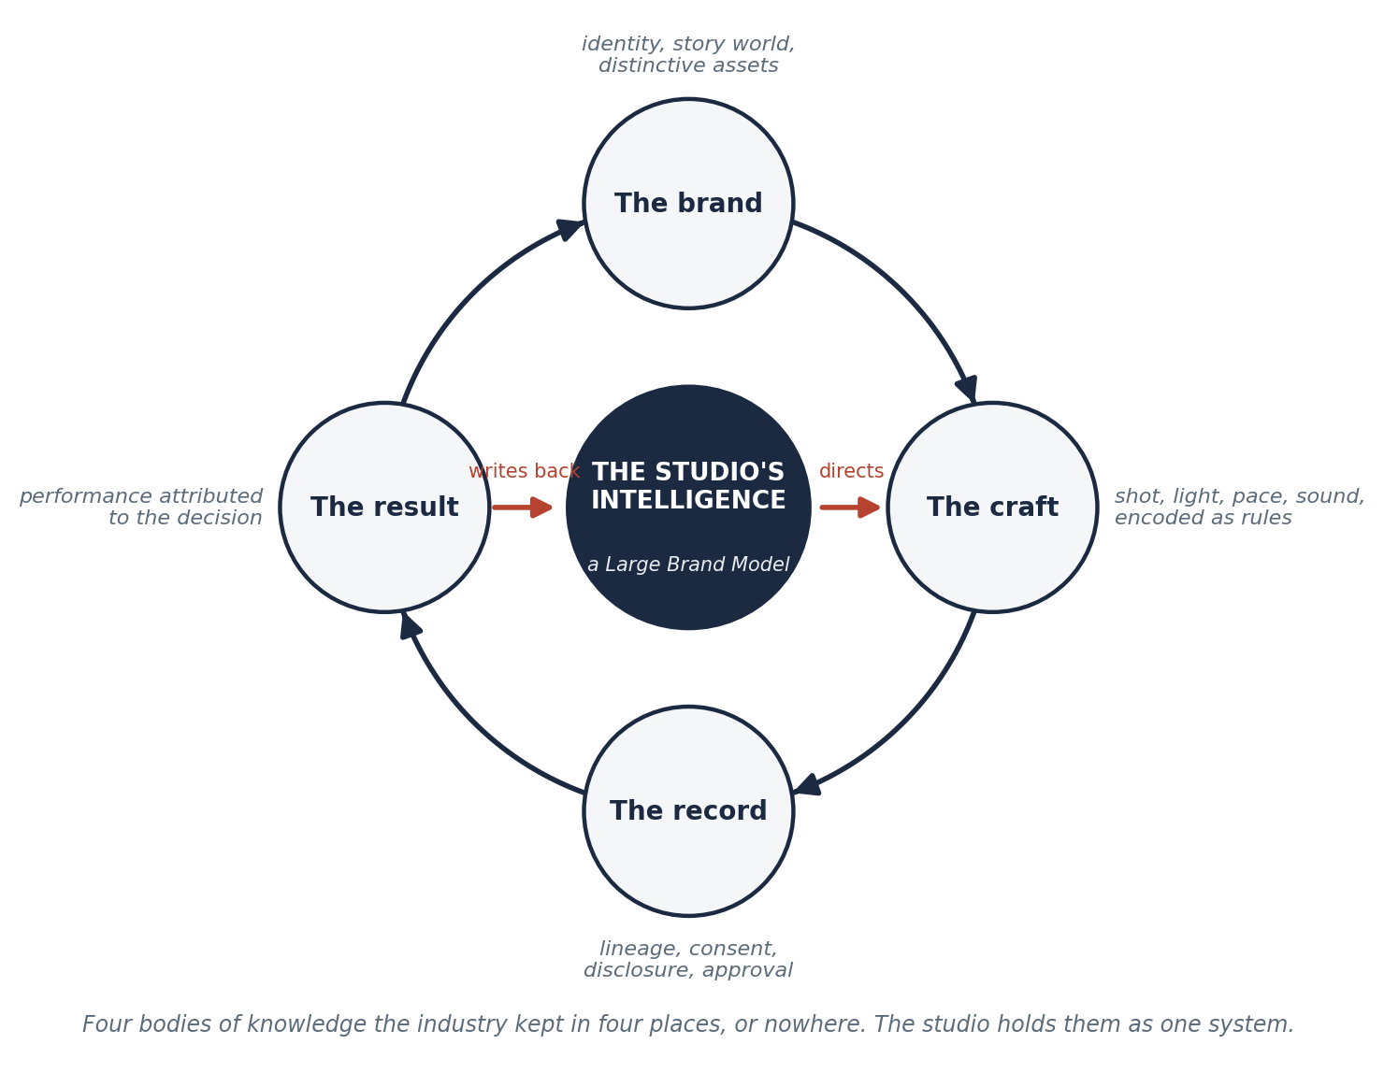
Figure 1. The studio's intelligence loop. Brand, craft, record, and result are one system. Performance is written back against the creative decisions that produced it, which is possible only because the studio made the work and governed the approval.

Prediction before spend
Intelligence of this kind can predict. System1 reports more than 250 validations of its star rating, and the IPA found that adding emotional-response scores to media spend data nearly doubles the accuracy with which market share growth can be predicted.⁴⁶ The neuroscience underneath is well established: Uri Hasson's laboratory showed that a speaker's brain activity couples with a listener's during successful communication, that the coupling vanishes when communication fails, and that the stronger the anticipatory coupling, the greater the understanding.⁴⁷ Paul Zak's work found that compelling narratives release oxytocin and shift attitudes and behavior.⁴⁸ A story either lands or it does not, the landing is measurable, and a studio that measures it before spend and learns from it after spend compounds an advantage that a production company, which leaves after delivery, never can.
Measurement stops at the edge of the frame. A studio's intelligence has to reach inside it.

Why the intelligence belongs to the brand
The four bodies of knowledge are the brand's. A Cinematic Intelligence Studio holds them on the brand's behalf and in the brand's name, in a form that persists across models, campaigns, agencies, and staff. That is the Large Brand Model of Section 3. The studio is the institution that keeps it current, because it is the institution that makes the work the model learns from.

6. Studio: The Operating Model
The word studio has a history, and the history is instructive. The classical Hollywood studios owned "production facilities, distribution networks, and often movie theaters," and eight of them controlled roughly 95 percent of American film production.⁴⁹ In 1948 the Supreme Court ended the arrangement, ordering the studios to divest their theaters and end block booking.⁵⁰ The lesson usually drawn is that vertical integration was the sin. The more useful lesson is that the studios integrated the wrong thing. They owned the screens. What made them studios was that they owned the means of making, the craft, and the accountability for the result, in one institution.
A Cinematic Intelligence Studio integrates the right thing. It does not own distribution, and it does not own the generation models. It owns the intelligence and the craft, and it runs the workflow that connects a brief to a result.

From brief to performance
The workflow has a shape. A brief enters a system that already knows the brand's constraints and history. Candidates are generated inside the brand's grammar, by whichever models best serve the shot, and refused when they fall outside it. Humans direct: a director and a producer make the creative decisions, review the candidates, and approve, and every approval is recorded with its lineage. The work ships. Performance returns to the system that made the decisions, attributed to the decisions themselves. The next brief begins with more than the last one did.
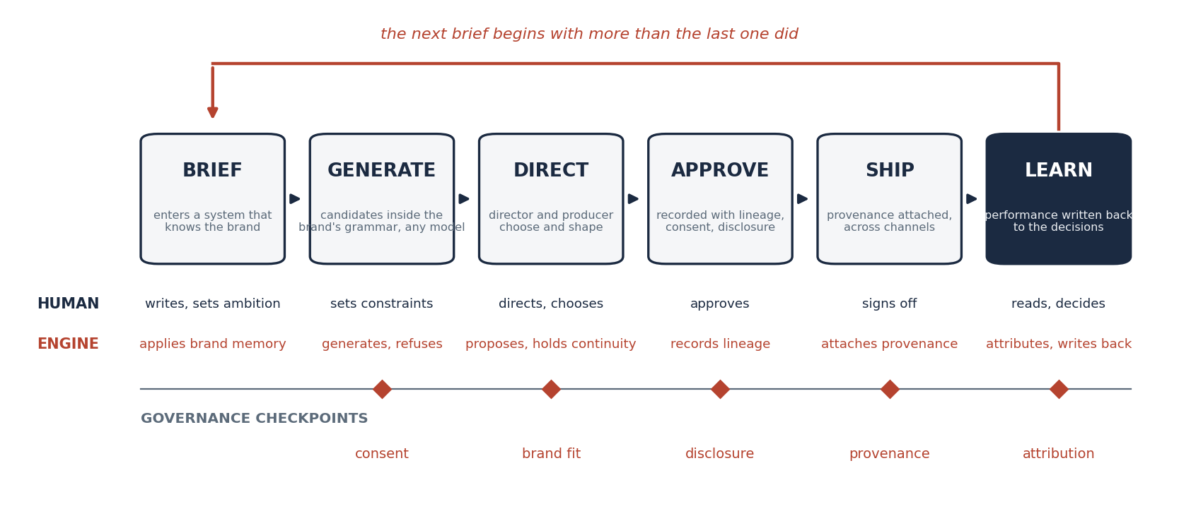
Figure 2. The studio's operating model, brief to performance. Human direction at every creative decision, machine assistance at every step where assistance is possible, and governance checkpoints for consent, disclosure, and provenance built into the flow rather than bolted on after it.
Two roles carry the model. The director holds the creative ambition and the taste: what the story is, how it should feel, which candidate is right. The producer holds the operation: the schedule, the approvals, the constraints, the record. Both existed in conventional production. What changes is that each now directs an engine as well as a crew, and that the engine remembers.

Governance is the product
A studio operates inside rules that a tool vendor never sees. The 2025 SAG-AFTRA commercials contract, ratified by 96.9 percent of members, requires performer consent before any digital replica is created, triggers a 1.5 times session fee when a replica generates a performance, forbids training on performer data without union consent, and requires unretained replicas to be destroyed.⁵¹ The 2023 television and theatrical agreement requires consent with "a reasonably specific description of the use" and notification when synthetic performers are created.⁵² The Writers Guild's 2023 agreement holds that AI cannot write or rewrite literary material and requires disclosure when material given to a writer was generated by AI.⁵³ The Academy's rule for the 98th Oscars states that AI tools "neither help nor harm the chances of achieving a nomination," and that the judgment rests on "the degree to which a human was at the heart of the creative authorship."⁵⁴
Provenance is becoming infrastructure. Sony now ships cameras that sign images at capture under the C2PA standard, described as a "digital birth certificate."⁵⁵ Amazon MGM's 2026 generative slate runs on a purpose-built production platform with provenance tracking, and its chief operating officer framed the principle as "human-centric. AI tools are meant to empower human creativity."⁵⁶ The case of The Brutalist, where an editor's disclosure that AI had refined Hungarian dialogue became a controversy after the fact, is the case for disclosing before.⁵⁷
A production company treats these rules as compliance. A Cinematic Intelligence Studio treats them as product. Consent, disclosure, and provenance are encoded in the workflow, checked at generation time, and recorded in the lineage of every asset. When a regulator, a guild, a partner, or a board member asks who approved something and on what basis, the answer is a query rather than an investigation.
The old studios owned the screens. The new studio owns the intelligence and the craft, and answers for the result.
AI-assisted, human-directed, brand-controlled. That is the operating principle in six words, and each word is load-bearing.

7. The Studio and the Models
The film industry has run the experiment this paper describes, in public, over 24 months, and the results point one way.
Lionsgate signed the first major-studio agreement with a model company in September 2024, a custom model trained on its own catalog for pre-production and post-production.⁸ By June 2026 it had hired a chief AI officer, taken an equity stake in Runway, and committed to a short-form slate built from its properties; Runway's chief executive observed that "the studios most serious about AI are thinking about it as a creative resource, not a cost-cutting tool."⁹ Netflix put the first generative footage into a finished original in 2025, a building collapse in El Eternauta, completed ten times faster than conventional visual effects would have allowed; its co-chief executive framed the opportunity as helping creators make films and series better, with cheaper as a byproduct rather than the goal.¹⁰ Amazon's House of David used roughly 70 generated images in its first season and 350 to 400 in its second, built with "10 to 15 core tools."⁵⁸⁵⁹
The counterexample is as instructive. Disney agreed in December 2025 to invest a billion dollars in OpenAI and license more than 200 characters to Sora for three years.⁶⁰ In March 2026 OpenAI announced Sora's discontinuation, and Disney exited the partnership roughly three months after signing it.¹¹ A studio that had bound its characters to one vendor's consumer product learned, at some expense, that a model is a product and products are retired.
Date | Event | What it shows
September 2024 | Lionsgate and Runway sign a custom-model agreement | Catalog-trained intelligence, held by the studio
November 2024 | Promise launches with backing from a16z and Peter Chernin | Investors fund AI-native studios, built "from the ground up"
July 2025 | Netflix puts generative footage in a finished original | The craft standard holds; the workflow changes
December 2025 | Disney licenses 200+ characters to Sora with a $1 billion investment | Betting the brand on one model
March 2026 | Sora is discontinued; Disney exits | The model was a product; the studio must hold the intelligence
May 2026 | Amazon MGM greenlights three series on a governed AI production platform | Provenance and governance become the pipeline
June 2026 | Lionsgate takes equity in Runway and hires a chief AI officer | From licensing a tool to owning a capability

Model-agnostic by design. The instruments are extraordinary and getting better every quarter. Google's Flow launched in 2025 as a filmmaking tool rather than a clip generator, with camera controls and scene extension for character consistency,⁶¹ and its later update added reference images to hold characters and objects across shots.⁶² Runway's Aleph can generate new angles of an existing scene and change its lighting,⁶³ and its Gen-4.5 topped the blind human-preference leaderboard while its own release notes listed object permanence as a remaining limitation.⁶⁴ Enterprise production deployments already use a median of 14 different models.⁶⁵ A studio that holds its craft and its brand knowledge above the models can use every one of them and survive the retirement of any. A studio built on one cannot.
The studios most serious about AI moved from licensing a tool to owning a capability. The capability is the intelligence.
An AI-native studio wave is forming around this insight. Promise launched in November 2024 on the premise that "a studio must be built from the ground up."⁶⁶ Asteria, co-founded by Natasha Lyonne and Bryn Mooser, announced a model trained only on licensed data on the argument that nothing else is usable.⁶⁷ Runway's AI Festival added an advertising track for 2026.⁶⁸ These are the early forms of the category. What distinguishes a Cinematic Intelligence Studio from them is that it is built for brands, and therefore built around a brand's intelligence rather than a studio's catalog.

8. What It Changes for Brands
Governed, repeatable, measurable. A brand that works with a Cinematic Intelligence Studio gets one institution accountable for the whole of a campaign, from brief to performance, instead of three institutions accountable for a piece each and none for the result.

What changes
The brief goes to one place. The studio holds the brand's knowledge, so the first candidates arrive inside the brand's grammar and review begins at creative judgment rather than at compliance. The film is made by people who direct engines, at a cadence the content demand of the 2020s requires and the production economics of the 2010s could not supply. Approval is an event with lineage. Performance returns to the decisions that produced it. The knowledge stays with the brand.

What the brand keeps
Everything that matters. The rules, the approvals, the creative ambition, the direction. The studio enforces what the brand has decided and remembers what it has approved; it does not decide for the brand. And the brand keeps the intelligence itself. The Large Brand Model at the center of the studio is the brand's asset. It persists when a generation model is retired, when a campaign ends, and when a relationship changes.

What the brand stops paying for
The handoffs. The re-briefing of every new agency, production partner, and tool from zero. The craft gap in the in-house team, which Forrester's data shows using generative AI at a fraction of the rate agencies do.²³ The governance that lived in people and was paid for in incidents; 70 percent of marketers have already lived through one, and among them 40 percent had to pause or pull ads.⁶⁹ The rebuilding of brand intelligence every time the model underneath it is deprecated.

What the audience gets
Trust, which is the thing the industry is spending down. Half of consumers say they prefer brands that avoid generative AI in consumer-facing content,⁷⁰ and 49 percent of Americans view business use of AI in advertising negatively.⁷¹ The same research shows the way through. Deloitte found that 39 percent of fans would accept AI-created content if it were clearly labeled,⁷² and Yahoo and Publicis found that a noticed AI disclosure produced a 73 percent lift in ad trustworthiness.⁷³ Kantar found that audiences reward AI they cannot see and punish AI they can.⁶ A studio that governs consent, disclosure, and craft as one discipline produces work that earns the trust the ungoverned work spends.
Three institutions accountable for a piece each and none for the result. Or one institution accountable for the whole.

9. Why the Studio Form Wins
Generation is commoditizing. Enterprise creative operations are not.
When a beautiful frame costs nothing, the institution that sold beautiful frames has no business, and the institutions around it reorganize. That reorganization is what Section 1 described: agencies consolidating into platforms, post houses closing, shoot days falling, brands pulling ideas inside and finding they cannot pull craft inside with them. Value migrates to whoever holds the thing that stays scarce, and three things stay scarce.
Craft stays scarce, because it is the largest lever on results and the hardest to hold in motion. Nearly half of media impact is creative quality,⁴ five-star work is four percent of all work,³² and the public record of AI advertising is a record of craft failing at scale.
Intelligence stays scarce, because a brand's knowledge of itself does not exist in any general model and cannot be prompted or fine-tuned into one durably. The industry's own intelligence vendors stop at measurement.⁷ The knowledge of what to make, in the language of a director, held in a system that persists, is held nowhere today.
Accountability stays scarce, because the handoffs that structured the industry were built to distribute it. The most consistent brands generate 27 percent more very large brand effects than inconsistent ones,⁷⁴ and consistency across a thousand variants is an institutional property, not an individual one.
The studio form holds all three. It always did. What broke the classical studio was owning the screens; what makes the new one durable is owning the intelligence and the craft while treating the screens and the models as what they have become, which is interchangeable. The film industry has reached the same conclusion from the other direction: the studios most serious about AI moved from licensing a tool to owning a capability, and the one that bet its characters on a single product got three months out of the bet.⁹¹¹
Craft stays scarce. Intelligence stays scarce. Accountability stays scarce. The studio is the institution that holds all three.
Categories become real when they are named tightly enough for others to use. This paper offers the name and the definition. The institution it describes will be built by more than one company, in more than one form, and the brands that recognize it first will be the ones whose creative compounds while their competitors' resets with every model release.

10. Conclusion: The Studio Returns
The studio was always the right idea and the wrong integration. It held craft, making, and accountability under one roof and then chained them to real estate. The court took the real estate away, and the industry spent seventy years distributing what remained across agencies, production companies, post houses, and now tool vendors, each holding a piece and none holding the whole.
Abundance has ended that arrangement. The machines make endlessly, beautifully, and indifferently, for any brand and no brand. What they cannot do is know: which frame belongs to this brand, who approved the last one, why the one before it was refused, what the slow reveal did that the fast cut did not. What they cannot do is direct: hold a character steady for 240 frames, light a face so the story reads, cut so the audience never sees the cut. And what they cannot do is answer for the result.
A Cinematic Intelligence Studio is the institution that can. It makes cinematic work, because cinema is where the value and the difficulty both live. It holds a brand's intelligence, because that intelligence is the scarce asset and it belongs to the brand. And it runs the whole, from brief to performance, under one roof, because accountability distributed is accountability lost.
Cinematic. Intelligence. Studio. Three words, one institution.
The machines make. They cannot know, they cannot direct, and they cannot answer for the result. The studio can.
AI-assisted, human-directed, brand-controlled. The studio returns, integrated around the right thing this time.

Putting the Definition into Practice
Ritual Ads is a cinematic intelligence studio, powered by Ritual Engine.
Ritual Ads makes cinematic commercial creative for enterprise brands through the operating model this paper describes: one governed system that carries a campaign from brief to performance, across any AI model, directed by people who have spent their careers on set and in the edit. Ritual Engine is Ritual Ads' implementation of the Large Brand Model architecture for cinematic commercial creative, the persistent intelligence at the center of the studio that holds each brand's voice, visual grammar, story world, approval history, and performance record, and uses it to direct, constrain, and evaluate the generation models producing work on the brand's behalf.
The studio begins with motion because motion is the hardest case and the most valuable. Stills, key art, and cutdowns are produced from the same governed intelligence. Brands, agencies, and production partners plug in whatever generation models they choose, and Ritual Engine governs the process around them.
AI-assisted, human-directed, brand-controlled.

Glossary
Cinematic Intelligence Studio (CIS). An institution that produces cinematic commercial creative through a persistent, governed intelligence rather than through conventional production alone; it holds craft, brand intelligence, and an accountable brief-to-performance operating model in one place and treats generation models as interchangeable instruments.
Cinematic. The discipline of moving images: light, lens, performance, pacing, sound, and continuity, governed by a grammar in which every choice serves the story.
Intelligence. In this paper, a brand-specific, persistent body of knowledge with four parts: the brand, the craft, the record, and the result. Distinct from "creative intelligence" as the measurement industry uses the term.
Studio. An institution that makes the work, owns the means of making it, and answers for the result, as distinct from an agency, a vendor, or a platform.
Large Brand Model (LBM). A persistent, model-agnostic intelligence that encodes a single brand's identity, cinematic grammar, governance history, and performance record and uses it to direct, constrain, and evaluate any generation model. The architecture at the center of a Cinematic Intelligence Studio.
Brief to performance. The span of the workflow the studio governs, from the initial brief through generation, approval, and distribution to measured results.
Lineage. The recorded history of an asset: brief, model, reviewers, changes, refusals, consents, disclosures, and approvals.
Provenance. Verifiable evidence of how an asset was created, including the C2PA content-credentials standard now supported at capture by camera manufacturers.
Digital replica. Under SAG-AFTRA agreements, a synthetic reproduction of a performer's voice or likeness, requiring consent before creation and use.
Model-agnostic. An architecture in which the studio's intelligence is independent of any single generation model and can route work to any model without loss of knowledge.
Compound creativity. The finding, from the IPA and System1, that creative consistency produces cumulative brand and business effects over time.
Attention-memory threshold. Amplified Intelligence's finding that roughly 2.5 seconds of attention is the point at which advertising begins to form lasting memory.
Right-brain features. In Orlando Wood's analysis for the IPA, the elements of advertising, metaphor, music, character, humor, place, that map to broad and lasting business effects.
Ritual Engine. Ritual Ads' implementation of the Large Brand Model architecture for cinematic commercial creative.

Notes
Sources are numbered in order of first citation. Each was retrieved and verified between September 1 and September 5, 2026. Where a figure is self-reported by a vendor or trade body, the text says so.
1. Gideon Spanier. "Omnicom Reveals Huge Agency Shake-Up, Unveils New Leadership, Cuts 4,000 Jobs." Campaign, December 1, 2025. https://www.campaignlive.com/article/omnicom-reveals-huge-agency-shake-up-unveils-new-leadership-cuts-4000-jobs/1941618
2. Brittaney Kiefer. "Six Production Studios to Watch After The Mill and MPC's Shutdown." Adweek, February 27, 2025. https://www.adweek.com/creativity/six-production-studios-to-watch-after-the-mill-and-mpcs-shutdown/
3. FilmLA. "Rising California Film & TV Tax Credit Productions Signal Growing Industry Momentum Amid 2025 Production Losses." FilmLA, January 15, 2026. https://filmla.com/rising-california-film-tv-tax-credit-productions-signal-growing-industry-momentum-amid-2025-production-losses/
4. Kantar. "Creative Effectiveness: What We've Learned From French Cannes Winners." Kantar, July 26, 2023. https://www.kantar.com/inspiration/advertising-media/creative-effectiveness-what-weve-learned-from-french-cannes-winners
5. Les Binet and Peter Field. "The Long and the Short of It." Thinkbox research summary, December 6, 2012 (IPA, 2013). https://www.thinkbox.tv/research/thinkbox-research/the-long-and-the-short-of-it
6. Ecem Erdem and Věra Šídlová. "Rethinking AI-Generated Advertising: How Real People Really React." Kantar, November 4, 2025. https://www.kantar.com/inspiration/advertising-media/rethinking-ai-generated-advertising
7. Winterberry Group. "Creative Intelligence: Adopting and Operationalizing Creative Intelligence." Reported by Analytic Partners, February 3, 2026. https://analyticpartners.com/knowledge-hub/newsroom/winterberry-group-documents-burgeoning-creative-intelligence-market-for-advertising/
8. Runway. "Runway Partners with Lionsgate." Runway Newsroom, September 18, 2024. https://runway.com/news/runway-partners-with-lionsgate
9. Corbin Bolies. "Lionsgate Takes Equity Stake in Runway AI, Plans to Draw on Existing Properties for AI-Generated Short-Form Series." Variety, June 11, 2026. https://variety.com/2026/film/news/lionsgate-equity-stake-runway-ai-franchises-for-ai-show-1236775590/
10. Ivan Mehta. "Netflix Starts Using GenAI in Its Shows and Films." TechCrunch, July 18, 2025. https://techcrunch.com/2025/07/18/netflix-starts-using-genai-in-its-shows-and-films/
11. EMARKETER. "OpenAI to Discontinue Sora App as Disney Exits Partnership." EMARKETER, March 25, 2026. https://www.emarketer.com/content/openai-discontinue-sora-app-disney-exits-partnership
12. MediaPost. "4As: Costs Rose for Spots; Agency Markup Came Down." MediaDailyNews, December 24, 2011. https://www.mediapost.com/publications/article/164727/4as-costs-rose-for-spots-agency-markup-came-down.html
13. Vivek Pandya. "Adobe Research Finds Demand for Content Will Grow 5x by 2027." Adobe Blog, June 16, 2025. https://business.adobe.com/blog/71-percent-of-marketers-say-content-demand-to-increase-5x
14. Omnicom Group. "Omnicom Completes Acquisition of Interpublic, Forming the World's Leading Marketing and Sales Company." Omnicom Press Release, November 26, 2025. https://www.omc.com/newsroom/omnicom-completes-acquisition-of-interpublic-forming-the-worlds-leading-marketing-and-sales-company-built-for-intelligent-growth-in-the-next-era/
15. Encyclopaedia Britannica. "William Bernbach." Britannica Money, accessed September 7, 2026. https://www.britannica.com/money/William-Bernbach
16. Reuters. "WPP Plunges After New CEO Starts With a Profit Warning." The Star, November 3, 2025. https://www.thestar.com.my/business/business-news/2025/11/03/wpp-plunges-after-new-ceo-starts-with-a-profit-warning
17. Marisa Jones. "How the Top Advertising Groups Performed in 2025, and What to Expect in 2026." EMARKETER, January 5, 2026. https://www.emarketer.com/content/how-top-advertising-groups-performed-2025-and-what-expect-2026
18. WPP plc. "Strategy Update and 2025 Preliminary Results." WPP, February 26, 2026. https://www.wpp.com/en/news/2026/02/strategy-update-and-2025-preliminary-results
19. Sam Anderson. "Forrester Predicts 15% Agency Job Losses in 2026. Is the 'Agencies as Agents' Era Over?" The Drum, October 3, 2025. https://www.thedrum.com/news/forrester-predicts-15-agency-job-losses-2026-the-agencies-agents-era-over
20. Association of National Advertisers. "In-House Agencies No Longer a Trend, They're Here to Stay: ANA Report." ANA Press Release, May 2, 2023. https://www.ana.net/content/show/id/79185
21. Association of National Advertisers. "The Resilient Rise of the In-House Agency: 2026 State of In-Housing Report." ANA Research, June 22, 2026. https://www.ana.net/miccontent/show/id/rr-2026-06-resilient-rise-in-house
22. In-House Agency Leaders Club. "ANA Report Finds IHAs 'More Capable, More Strategic.'" IHALC, July 22, 2026. https://www.ihalc.com/insights/ana-report-finds-ihas-more-capable-more-strategic/
23. Forrester. "Predictions 2025: Agencies Jettison Legacy Structures to Form New Agency Types." Forrester Blog, 2024. https://www.forrester.com/blogs/predictions-2025-marketing-agencies
24. David Bordwell, Kristin Thompson, and Jeff Smith. Film Art: An Introduction, 13th ed. McGraw Hill. https://www.mheducation.com/highered/product/film-art-an-introduction-bordwell.html
25. Encyclopaedia Britannica. "Motion-Picture Technology: Introduction of Sound." Britannica, accessed September 7, 2026. https://www.britannica.com/technology/motion-picture-technology/Introduction-of-sound
26. Encyclopaedia Britannica. "Anamorphic Lens." Britannica, accessed September 7, 2026. https://www.britannica.com/technology/anamorphic-lens
27. Oxford Reference. "Continuity Editing." A Dictionary of Media and Communication, Oxford University Press. https://www.oxfordreference.com/display/10.1093/oi/authority.20110803095635173
28. American Society of Cinematographers. "About." ASC, accessed September 7, 2026. https://theasc.com/about/
29. NPR. "Roger Deakins, Keeping an Eye on the Small Things." All Things Considered, October 29, 2009. https://www.npr.org/transcripts/114249616
30. Michael Lee. "Effectiveness in Context, Reviewed by Michael Lee." IPA Blog, November 15, 2018. https://ipa.co.uk/knowledge/ipa-blog/effectiveness-in-context-reviewed-by-michael-lee
31. NCSolutions. "Five Keys to Advertising Effectiveness" (2023 update). NCSolutions, August 2023. https://info.ncsolutions.com/hubfs/2023%20Five%20Keys%20to%20Advertising%20Effectiveness/NCS_Five_Keys_to_Advertising_Effectiveness_E-Book_08-23.pdf
32. System1 Group. "The System1 Guarantee: How? What? Why?" System1 Blog, November 3, 2017. https://system1group.com/blog/the-system1-guarantee-how-what-why
33. LBBOnline. "IPA Publishes Lemon: A Repair Manual to Reverse the Crisis in Creative Effectiveness." LBBOnline, October 15, 2019. https://lbbonline.com/news/ipa-publishes-lemon-a-repair-manual-to-reverse-the-crisis-in-creative-effectiveness
34. IPA. "Look Out! Advertising's Effectiveness Problem Is Staring Us in the Face." IPA News, October 12, 2021. https://ipa.co.uk/news/look-out
35. John-Anthony Disotto. "Coca-Cola's Iconic 'Holidays Are Coming' Ad Is Now a Soulless and Creepy Dystopian Nightmare Made by AI." TechRadar, November 15, 2024. https://www.techradar.com/computing/artificial-intelligence/coca-colas-iconic-holidays-are-coming-ad-is-now-a-soulless-and-creepy-dystopian-nightmare-made-by-ai
36. Steven Zeitchik. "Coca-Cola Is Trying Another AI Holiday Ad. Executives Say This Time Is Different." The Hollywood Reporter, November 3, 2025. https://www.hollywoodreporter.com/business/digital/coke-new-ai-holiday-ad-video-1236416491/
37. Trishla Ostwal. "AI Took Over the Super Bowl, Accounting for 23% of Ads." Adweek, February 8, 2026. https://www.adweek.com/brand-marketing/super-bowl-revealed-ai-messaging-crisis/
38. Lauren Forristal. "From Svedka to Anthropic, Brands Make Bold Plays With AI in Super Bowl Ads." TechCrunch, February 8, 2026. https://techcrunch.com/2026/02/08/super-bowl-60-ai-ads-svedka-anthropic-brands-commercials/
39. Amplified Intelligence. "Why Does the Attention-Memory Threshold Matter?" Amplified Intelligence, June 27, 2022. https://www.amplified.co/insight/why-does-the-attention-memory-threshold-matter
40. VCCP Media and Karen Nelson-Field. "Hacking the Attention Economy: VCCP Media and Dr Karen Nelson-Field Reveal 1.5 Second Formula for Effective Digital Advertising." VCCP, May 16, 2025. https://www.vccp.com/uk/news/2025/may/hacking-the-attention-economy-vccp-media-and-dr-karen-nelson-field-reveal-1-5-second-formula-for-effective-digital-advertising
41. Wendy Parish. "Brand Lift Happens in Less Than 1 Second of Video, Study Finds." Marketing Dive, March 19, 2015. https://www.marketingdive.com/news/brand-lift-happens-in-less-than-1-second-of-video-study-finds/377333/
42. Vidmob. "What Is Creative Intelligence?" Vidmob Help Center, accessed September 7, 2026. https://help.vidmob.com/en/articles/3443376-what-is-creative-intelligence
43. CreativeX. Homepage. CreativeX, accessed September 7, 2026. https://www.creativex.com/
44. Forrester. "Learning From Limes and Forrester's Creative AdTech Landscape." Forrester Blog, n.d. https://www.forrester.com/blogs/learning-from-limes-and-forresters-creative-adtech-landscape/
45. Jenni Romaniuk. Building Distinctive Brand Assets. Oxford University Press, May 16, 2018. https://global.oup.com/academic/product/building-distinctive-brand-assets-9780190311506
46. System1 Group. "Methodology." System1, accessed September 7, 2026. https://system1group.com/methodology
47. Greg J. Stephens, Lauren J. Silbert, and Uri Hasson. "Speaker-Listener Neural Coupling Underlies Successful Communication." Proceedings of the National Academy of Sciences 107, no. 32 (August 10, 2010): 14425-14430. https://www.pnas.org/doi/10.1073/pnas.1008662107
48. Paul J. Zak. "Why Inspiring Stories Make Us React: The Neuroscience of Narrative." Cerebrum: The Dana Forum on Brain Science, June 2, 2015. https://www.researchgate.net/publication/277599941_Why_Inspiring_Stories_Make_Us_React_The_Neuroscience_of_Narrative
49. Encyclopaedia Britannica. "Studio System." Britannica, accessed September 7, 2026. https://www.britannica.com/topic/studio-system
50. EBSCO Research Starters. "United States v. Paramount Pictures, et al." EBSCO, accessed September 7, 2026. https://www.ebsco.com/research-starters/law/united-states-v-paramount-pictures-et-al
51. SAG-AFTRA. "2025 Commercials Contracts." SAG-AFTRA, ratified May 21, 2025. https://www.sagaftra.org/contracts-industry-resources/commercials/2025-commercials-contracts
52. SAG-AFTRA. "Regulating Artificial Intelligence: TV/Theatrical 2023." SAG-AFTRA, 2023. https://www.sagaftra.org/sites/default/files/sa_documents/AI%20TVTH.pdf
53. Writers Guild of America East. "Summary of the 2023 WGA MBA." WGA East, 2023. https://www.wgaeast.org/guild-contracts/mba/summary-of-the-2023-wga-mba/
54. Academy of Motion Picture Arts and Sciences. "Awards Rules and Campaign Promotional Regulations Approved for 98th Oscars." Academy Press Office, April 21, 2025. https://press.oscars.org/news/awards-rules-and-campaign-promotional-regulations-approved-98th-oscarsr
55. Sony Electronics. "Sony Electronics Delivers Firmware Updates Including C2PA Compliancy as a Next Step to Ensure Authenticity of Images." PR Newswire, March 27, 2024. https://www.prnewswire.com/news-releases/sony-electronics-delivers-firmware-updates-including-c2pa-compliancy-as-a-next-step-to-ensure-authenticity-of-images-302101879.html
56. Todd Spangler. "Amazon MGM Studios Greenlights Three AI Series for Prime Video Under New GenAI Creators' Fund." Variety, May 27, 2026. https://variety.com/2026/tv/news/amazon-mgm-studios-genai-creators-fund-greenlights-series-1236759131/
57. ANI. "'We Wanted to Perfect It,' Says Editor David Jancso After Taking Help of AI for Hungarian Dialogues in 'The Brutalist.'" ANI News, January 21, 2025. https://www.aninews.in/news/entertainment/hollywood/we-wanted-to-perfect-it-says-editor-david-jancso-after-taking-help-of-ai-for-hungarian-dialogues-in-the-brutalist20250121134738/
58. Amazon MGM Studios. "House of David Uses AI to Bring Epic Visuals to Life." Amazon MGM Studios Press, March 21, 2025. https://press.amazonmgmstudios.com/us/en/press-release/ihouse-of-davidi-uses-ai-to-bring-epic-visuals-to-
59. Alex Welch. "House of David Season 2 Features Over 350 AI-Generated Images." TheWrap, November 10, 2025. https://www.thewrap.com/house-of-david-season-2-showrunner-pro-ai-shots/
60. The Walt Disney Company. "The Walt Disney Company and OpenAI Reach Agreement to Bring Disney Characters to Sora." Disney Newsroom, December 11, 2025. https://thewaltdisneycompany.com/news/disney-openai-sora-agreement/
61. Google. "Introducing Flow: Google's AI Filmmaking Tool Designed for Veo." The Keyword, May 20, 2025. https://blog.google/innovation-and-ai/products/google-flow-veo-ai-filmmaking-tool/
62. Google. "Bringing New Veo 3.1 Updates Into Flow to Edit AI Video." Google Blog, October 15, 2025. https://blog.google/innovation-and-ai/products/veo-updates-flow/
63. Runway. "Introducing Runway Aleph." Runway Research, July 25, 2025. https://runway.com/research/introducing-runway-aleph
64. Runway. "Introducing Runway Gen-4.5." Runway Research, December 1, 2025. https://runway.com/research/introducing-runway-gen-4.5
65. Jennifer Li and Justine Moore. "The State of Generative Media 2026." Andreessen Horowitz, February 19, 2026. https://a16z.com/the-state-of-generative-media-2026/
66. Lucas Manfredi. "Peter Chernin's The North Road Company, Andreessen Horowitz Invest in Generative AI Content Studio." TheWrap, November 19, 2024. https://www.thewrap.com/generative-ai-content-studio-promise-launch/
67. Asteria and Moonvalley. "Asteria and Moonvalley Announce the First Clean AI Model for Hollywood." PR Newswire, December 17, 2024. https://www.prnewswire.com/news-releases/asteria-and-moonvalley-announce-the-first-clean-ai-model-for-hollywood-302334001.html
68. Runway. "AIF 2026." Runway AI Festival, accessed September 7, 2026. https://aif.runwayml.com/
69. IAB. "AI Adoption Is Surging in Advertising, but Is the Industry Prepared for Responsible AI?" IAB Insights, August 21, 2025. https://www.iab.com/insights/ai-adoption-is-surging-in-advertising-but-is-the-industry-prepared-for-responsible-ai/
70. Gartner. "Gartner Marketing Survey Finds 50% of Consumers Prefer Brands That Avoid Using GenAI in Consumer-Facing Content." Gartner Newsroom, March 16, 2026. https://www.gartner.com/en/newsroom/press-releases/2026-03-16-gartner-marketing-survey-finds-50-percent-of-consumers-prefer-brands-that-avoid-using-genai-in-consumer-facing-content0
71. Julie Ray. "Americans Aren't Sold on Businesses Using AI in Advertising." Gallup, August 19, 2026. https://news.gallup.com/poll/713222/americans-aren-sold-businesses-using-advertising.aspx
72. Deloitte. "2026 Digital Media Trends: Capturing Always-On Fandom Between Releases and Seasons." Deloitte Insights, March 25, 2026. https://www.deloitte.com/us/en/insights/industry/technology/digital-media-trends-consumption-habits-survey.html
73. Yahoo Inc. "Yahoo & Publicis Media Survey Reveals AI Ad Disclosure Increases Consumer Trust." Yahoo Inc. Press Release, February 28, 2024. https://www.yahooinc.com/press/yahoo-publicis-media-survey-reveals-ai-ad-disclosure-increases-consumer-trust
74. IPA. "How Creative Consistency Strengthens Brands and Business Effects." IPA News, October 9, 2024. https://ipa.co.uk/news/creative-consistency

About Ritual Ads
Ritual Ads is a cinematic intelligence studio, powered by Ritual Engine.
Ritual Ads is the operating and decision layer for enterprise commercial creative. One governed system carries a campaign from brief to performance, across any AI model. Ritual Engine, the intelligence at the center of that system, is Ritual Ads' implementation of the Large Brand Model architecture for cinematic commercial creative.
The company was founded by Jethro Rothe-Kushel, a 25-year veteran of cinematic production who served as a national board member and vice president of the Producers Guild of America. His career spans technology, production, and marketing, including work with Apple, Netflix, and American Express, and began in 1999 as a presidential research scholar in artificial intelligence and video sciences at Dartmouth College.
Ritual Ads is headquartered in Beverly Hills, California.
AI-assisted, human-directed, brand-controlled.

