A RITUAL ADS WHITE PAPER
The Large Brand Model
Why Every Brand Will Need Its Own Intelligence

Jethro Rothe-Kushel
Founder and Chief Executive Officer, Ritual Ads, Inc.
September 2026
AI made creative abundant. Abundance doesn't raise the value of making things. It raises the value of controlling them.
Ritual Ads is a cinematic intelligence studio, powered by Ritual Engine.

Executive Summary
AI can generate nearly unlimited creative. What it cannot reliably retain is everything a company knows about its own brand: what looks right, what sounds right, what has been approved, what has failed, and what has worked. A Large Brand Model is the persistent intelligence layer that holds that knowledge and applies it across whatever AI models the brand uses.
Defined precisely, a Large Brand Model (LBM) is a persistent, model-agnostic intelligence that encodes a single brand's identity, cinematic grammar, governance history, and performance record, and uses that encoding to direct, constrain, and evaluate any generation model producing creative on the brand's behalf. Where a large language model is trained on the world, a Large Brand Model is trained on one brand. Where generation models turn over every few months, the LBM persists. It sits above the models and governs them.
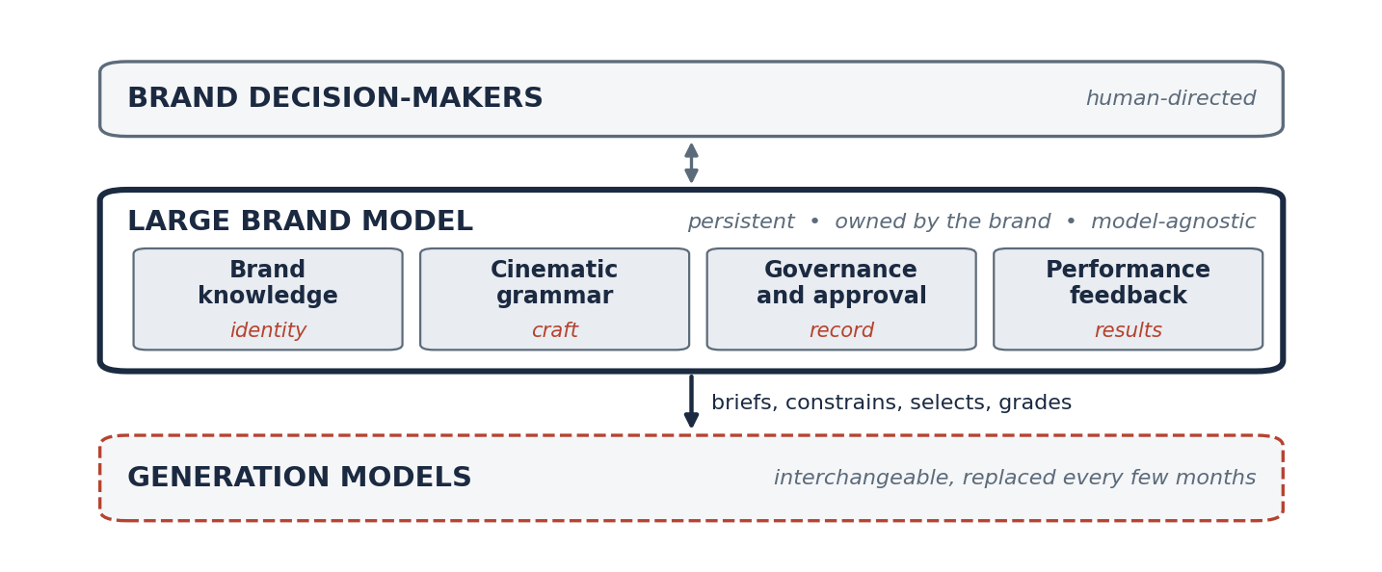
Figure A. The Large Brand Model in one view. Human decision-makers above, interchangeable generation models below, and a persistent brand intelligence between them that holds identity, craft, governance, and performance.
The case rests on an inversion. AI made creative abundant. Abundance doesn't raise the value of making things. It raises the value of controlling them. Eighty-six percent of video advertisers are using or plan to use generative AI to build creative.¹ Only 30 percent of CMOs say their organizations are ready to scale AI,² and 70 percent of marketers have already lived through at least one AI incident, from hallucinated claims to off-brand output.³ The bottleneck has moved from production to control, and control comes down to four questions: does it hold the brand, who approved it, can we repeat it, did it work.
Three conclusions follow. General models cannot answer those questions, because the answers are specific to one brand and change with every campaign. No single generation model can be the vessel for that knowledge, because the model layer is churning too fast to be a foundation.⁴ The durable asset is therefore the layer that persists across models: the brand's own intelligence. Generation is commoditizing. Enterprise creative operations are not.
Contents

1. The Problem: Creative Became Abundant
Every technology that makes something abundant moves value somewhere else. Printing made text abundant and moved value to editing. Recorded music made performance abundant and moved value to curation and rights. Cloud computing made servers abundant and moved value to orchestration. The pattern is old. Its latest instance is unfolding in commercial creative right now.
AI made creative abundant. Abundance doesn't raise the value of making things. It raises the value of controlling them.
The abundance is measurable. Half of video advertisers already use generative AI to build video ad creative, and the IAB projects that 40 percent of all video ads will be generative AI creative by 2026.¹ Meta reported more than eight million advertisers using at least one of its generative AI creative tools in the first quarter of 2026.⁵ EMARKETER forecasts that AI-powered ad spend in the United States will reach $57 billion in 2026, up 63 percent in a year, while spend without AI grows at roughly 5 percent.⁶ Midjourney priced its first video model at about eight times the cost of an image job, which it described as more than 25 times cheaper than what the market had previously shipped.⁷ The marginal cost of a frame is collapsing toward zero.
When the marginal cost of a frame approaches zero, the frame stops being the scarce thing. The scarce thing becomes the set of judgments that surround it. A campaign that could once be produced twenty cuts at a time can now be produced twenty thousand variants at a time, and every one of those variants is a decision somebody is accountable for.
When the marginal cost of a frame approaches zero, the frame stops being the scarce thing. The scarce thing becomes the set of judgments that surround it.
The consequences are already visible in market. The 2024 Coca-Cola holiday spot, produced entirely with AI, hid Santa's face because the models could not hold him steady.⁸ A year later, McDonald's Netherlands withdrew an AI-generated Christmas advert after public criticism, and a critic noted that the truck at the center of Coca-Cola's own spot seemed different in every frame.⁹ Google withdrew its "Dear Sydney" Gemini spot from Olympics rotation after backlash, noting that the ad had tested well before airing.¹⁰ Those are the failures visible from the outside. The ones that matter more are invisible: a tone slightly off, a color a shade wrong, a claim the legal team never saw, repeated ten thousand times across a media plan.

2. The Four Questions Brands Now Have to Answer
Four questions carry the new scarcity. They are the questions a chief marketing officer is actually accountable for, and none of them is answered by generating more.
Question | What the brand needs
Does it hold the brand? | Persistent brand intelligence
Who approved it? | Governance and lineage
Can we repeat it? | Institutional memory
Did it work? | Performance learning

A Large Brand Model exists to answer these four questions continuously.
Does it hold the brand? Consistency is the thing that generation models are worst at and that brands are most dependent on. The IPA and System1's study of more than 4,000 ads from 56 brands found that consistent brands generate 27 percent more very large brand effects and 28 percent more very large business effects than inconsistent ones.¹¹¹² Holding the brand is a body of knowledge: voice, visual grammar, story world, and the meaning behind them, applied to every frame.
Who approved it? Abundant creative means abundant decisions. When a team produced twenty cuts a quarter, approval was a meeting. When a system can produce twenty thousand variants a week, approval is an architecture. Somebody, or something, must hold the record of what was cleared, by whom, under what conditions, and what was refused. Only 33 percent of marketers have adopted formal AI governance tools, and among the 70 percent who have experienced an AI incident, 40 percent had to pause or pull ads.³
Can we repeat it? A campaign that works once is an anecdote. A campaign that can be reproduced, extended, and adapted without starting over is an asset. Reproduction requires memory, and memory requires a place to live. Prompts are not memory. A production partner's hard drive is not memory. Neither survives a change in vendor, model, or staff.
Did it work? Marketing leaders report that demonstrating financial impact is their single greatest challenge, with 63 percent facing increased pressure from the CFO and half facing more from the board.¹³ Creative is the largest single driver of advertising's sales effect, responsible for 49 percent of incremental sales in NCSolutions' analysis of nearly 450 campaigns,¹⁴ and the same research finds that marketers estimate that contribution at 19 percent.¹⁵ The most valuable lever in the system is the one that is least measured.
When a system can produce twenty thousand variants a week, approval is an architecture.
These are governance questions. They are not production questions. The organizations that win the next decade of brand building will be the ones that answer them systematically, at the speed the models now demand. Answering them requires a new kind of model, and the model belongs to the brand.

3. What a Large Brand Model Is
Categories become real when they are defined tightly enough for others to use. "Customer data platform" was named in a 2013 blog post by the analyst David Raab and became an industry within three years.¹⁶ Scott Brinker's first marketing technology landscape catalogued roughly 150 companies in 2011; the 2025 edition catalogued 15,384.¹⁷¹⁸ In each case the name preceded the market and shaped it. What follows is offered in that spirit: a definition precise enough to be adopted, argued with, and built against.

Definition
A Large Brand Model (LBM) is a persistent, governed intelligence built around a single brand. It encodes what the brand looks like, sounds like, and stands for; how its stories are told in motion; what has been approved, revised, and refused, and by whom; and what has performed in market. It is not itself a generation model. It sits above generation models, briefing, constraining, selecting, and grading them, and it retains everything it learns when those models change. Its output is a decision rather than an asset: this is on brand, this is approved, this is repeatable, this worked. Where a large language model is trained on the world, a Large Brand Model is trained on one brand.
Where a large language model is trained on the world, a Large Brand Model is trained on one brand.

What it is not
An LBM is not a brand guidelines document, which describes rules but cannot enforce them. It is not a digital asset management system, which stores outputs but holds no judgment about them. It is not a fine-tuned generation model, for reasons Section 4 makes plain. It is not a prompt library, which is memory without state. And it is not a single vendor's proprietary model, because a brand's intelligence that can be held hostage by one vendor's roadmap is not the brand's intelligence at all.

Where it sits in the stack
An LBM does not replace every system in the marketing stack. It connects and operationalizes the brand-specific intelligence those systems already contain.
Existing tool | Primarily does | LBM adds
Digital asset management | Stores assets | Judgment about them
Brand guidelines | Describes rules | Enforces and learns rules
Workflow software | Routes approvals | Retains decision lineage
Analytics | Reports outcomes | Connects outcomes to creative decisions
Generation models | Produce assets | Brand-specific direction and control

Each of those prior tools solves a fragment of the problem. The LBM is the category that unifies the fragments into one system with one owner: the brand.

4. Why General Models Alone Are Not Enough
A general model is a remarkable instrument for a general problem. It has read more than any person and can imitate almost any style on request. That breadth is precisely why it cannot serve as a brand's intelligence. It knows everything, and therefore knows nothing in particular. It has the average of every brand, which is the same as having none. The Stanford group that coined the term "foundation model" in 2021 chose the word to underscore what they called the models' "critically central yet incomplete character."¹⁹ A foundation is meant to be built on. The question for a brand is what gets built on top, and who owns it.

Prompting is not memory
The first instinct of every marketing team encountering a general model is to describe the brand to it. Paste the guidelines. Attach the tone-of-voice document. Add the logo. This works for a single session and fails as a system, for three reasons.
A prompt is a request, and a request is not a rule. A model asked to stay on brand will usually try, will not always succeed, and has no mechanism to know when it has failed. The knowledge-retrieval literature has been explicit about this since 2020: a model's parametric memory has a limited ability "to access and precisely manipulate knowledge," which is why retrieval systems were developed to supplement it.²⁰ A prompt has no history. It does not know that a tagline was retired in March, that legal rejected a claim last quarter, or that the spot with the blue grade outperformed the spot with the warm grade. And a prompt does not scale across people. Two hundred marketers, each prompting differently, produce two hundred slightly different brands. Salesforce's 2026 State of Marketing found that 75 percent of marketers have adopted AI and 84 percent admit to running generic campaigns.²¹ Generic is the natural output of a general model prompted by a crowd. Prompts alone are not a durable system of brand memory.

Fine-tuning is not a sufficient foundation for persistent brand intelligence
The more sophisticated instinct is to fine-tune: take a generation model, train it on the brand's archive, and produce a bespoke instance with the brand in its weights. This is technically possible and strategically insufficient, for one reason above all others. Generation models turn over every few months, and a fine-tune dies with its base model.
Consider the record of the past 24 months. OpenAI released Sora as a standalone product in December 2024,²² released Sora 2 with synchronized audio in September 2025,²³ and discontinued the Sora web and app experiences on April 26, 2026, with the API scheduled to follow in September.²⁴ Disney had committed a billion dollars to the platform and reportedly learned of the shutdown less than an hour before the public did.²⁵ Google shipped Veo 2 in December 2024,²⁶ Veo 3 with native audio in May 2025,²⁷ and Veo 3.1 in October 2025.²⁸ Runway moved from Gen-4 in March 2025²⁹ to Gen-4.5 in December.³⁰ Kuaishou's Kling completed more than 20 iterations in its first year³¹ and shipped a 3.0 model in February 2026.³² On the image side, OpenAI replaced its own default image generator within nine months,³³³⁴ and Google's Gemini 2.5 Flash Image, released in August 2025, was superseded by a Pro version in November.³⁵³⁶
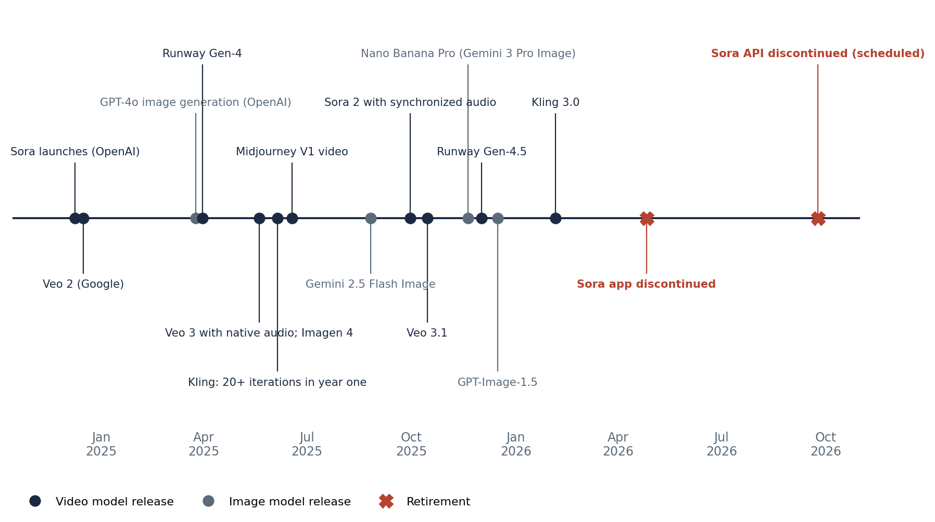
Figure 1. Major image and video generation model releases and retirements, December 2024 to September 2026. Each entry is drawn from the vendor's own announcement or the primary trade report cited in the notes. No single model has remained state of the art for more than a few months.
Andreessen Horowitz's 2026 review of generative media summarized the cadence plainly: model releases in 2025 came every four to six weeks, with no reason to expect the pace to slow, and enterprise production deployments now use a median of 14 different models.⁴ The platform vendors document the consequence. OpenAI's deprecation policy states that inference on fine-tuned models continues only until the base model is deprecated,³⁷ and Microsoft's model lifecycle policy specifies that once a model is retired, it is no longer available for fine-tuning and deployments return errors.³⁸
A fine-tune dies with its base model. A brand cannot store its identity in something that ships an obituary every six months.
A brand that fine-tunes a generation model is building its most valuable intelligence on a foundation with a published expiry date. Every retirement forces a rebuild. Every rebuild resets the accumulated learning. The lesson is not that generation models are bad. They are extraordinary and getting better every quarter. The lesson is that the brand's intelligence must live somewhere that does not depend on any one of them.

5. How the Large Brand Model Works
An LBM is composed of four layers. Each answers one of the four questions from Section 2, and each is a distinct body of knowledge that a general model cannot hold.
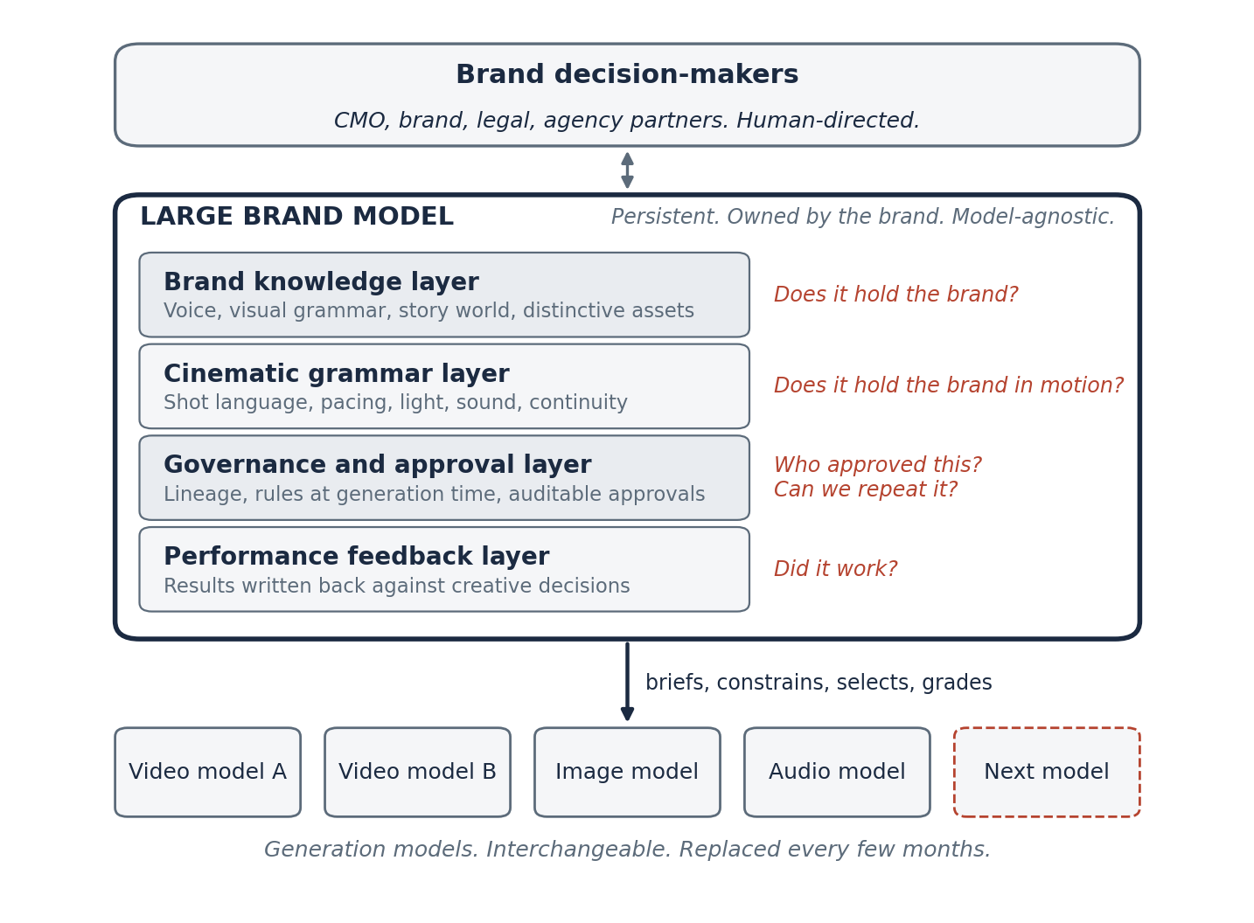
Figure 2. The Large Brand Model sits above interchangeable generation models and beneath the brand's human decision-makers. Each of its four layers answers one of the four questions.
The brand knowledge layer holds identity. Voice, tone, and vocabulary. Visual grammar: palette, typography, composition, the rules for how the logo lives in a frame. The story world: characters, settings, recurring motifs, the narrative territory the brand owns and the territory it avoids. Distinctive brand assets, in the sense established by the Ehrenberg-Bass Institute,³⁹ are encoded here as constraints, along with the meaning behind them. Kantar's analysis finds that visual assets account for roughly 30 percent of a brand's perceived difference, with the balance coming from positioning and experience,⁴⁰ which is why this layer must hold meaning and history and cannot be reduced to a style sheet. This layer answers: does it hold the brand?
The cinematic grammar layer holds craft. It encodes how the brand moves: shot language, pacing, lighting, sound design, transitions, the rhythm of a cut, the way a product is revealed, the way a face is lit. It knows the difference between a scene that belongs to the brand and a scene that merely contains its logo. This is the layer that separates a system built for commercial creative from a system built for text, and it answers the hardest part of "does it hold the brand," the part that no guideline document has ever been able to write down.
The governance and approval layer holds the record. Every asset carries its lineage: which model generated it, which brief produced it, who reviewed it, what was changed, what was rejected and on what grounds, which legal and regulatory constraints applied, and whether disclosure was required. The layer enforces rules at generation time rather than catching violations after publication, and it makes every decision auditable. It answers: who approved this, and can we repeat it?
The performance feedback layer holds the results. It connects each asset to what happened after it ran, and it writes what it learns back into the other three layers. A creative choice that lifts results becomes a preference. A choice that fails becomes a caution. This is the layer that turns a brand's archive into a compounding asset. It answers: did it work?

Model-agnostic by design
Model-agnostic by design. The phrase describes an architectural choice, and the choice follows directly from the churn documented in Section 4. If the generation layer turns over every few months, anything built to last must treat generation models as interchangeable components. An LBM routes a brief to whichever model best serves it today, and to a different model tomorrow, without losing a single thing it knows about the brand.
This is what makes an LBM stronger as models proliferate. Every new model is a new capability the brand can draw on: better motion, longer clips, native audio, finer control over a character's face. Every new model is also a new source of variance the brand must manage: a different house style, different failure modes, different tendencies to drift. A system that holds the brand independently of the models converts the first into an asset and neutralizes the second. The brand gains every improvement in the field and pays for none of the instability. It also means the brand, its agencies, and its production partners can adopt whatever generation tools they prefer without fracturing the brand's control. The LBM is the constant. Everything else is a plug-in.
Every new model is a capability the brand can draw on and a variance the brand must manage. A Large Brand Model converts the first into an asset and neutralizes the second.

The hardest case: motion
Video is where brands are made and where they are most easily broken. It carries voice, image, motion, music, performance, and narrative in a single object, and it is the form in which the largest share of brand-building investment is concentrated; the IPA's foundational analysis of long-term effectiveness recommended that roughly 60 percent of budgets be devoted to brand-building work,⁴¹ which has long been dominated by film. It is also the hardest thing for generation models to do consistently. A still image must be right once. A ten-second spot must be right 240 times in a row, and the character must be the same person in frame 240 as in frame one, in the same light, in the same world. Kantar's research on audience response to AI-generated advertising found that ads with seamless generative AI integration reached top-tier branded cut-through in more than 40 percent of cases, while ads with obvious AI elements performed noticeably worse.⁴² Audiences do not penalize AI. They penalize bad craft.
That asymmetry is why motion is the right case to design an LBM around. A system that can hold a character, a palette, a lighting scheme, and a story world steady across hundreds of frames can hold them steady in one. Stills, key art, social cutdowns, and display units become byproducts of the same governed intelligence. The reverse is not true. A system built for static graphics has no concept of pacing, performance, or continuity, and cannot be extended into motion without starting over.

6. The Learning Flywheel
Every campaign returns performance data that sharpens the next brief. That sentence is the mechanism by which a Large Brand Model compounds, and an example makes it concrete.
A brand approves three campaign concepts. One uses humor, one uses nostalgia, one uses product demonstration. The humor-led work performs substantially better with a particular audience. The LBM records more than "Campaign A won." It records which creative decisions contributed to the result: the opening, the pacing, the character, the claim. The next brief begins with that learning already applied. The nostalgia concept is not discarded; it is filed against the audience where it held, so the next time that audience is in the plan, the brief starts there.
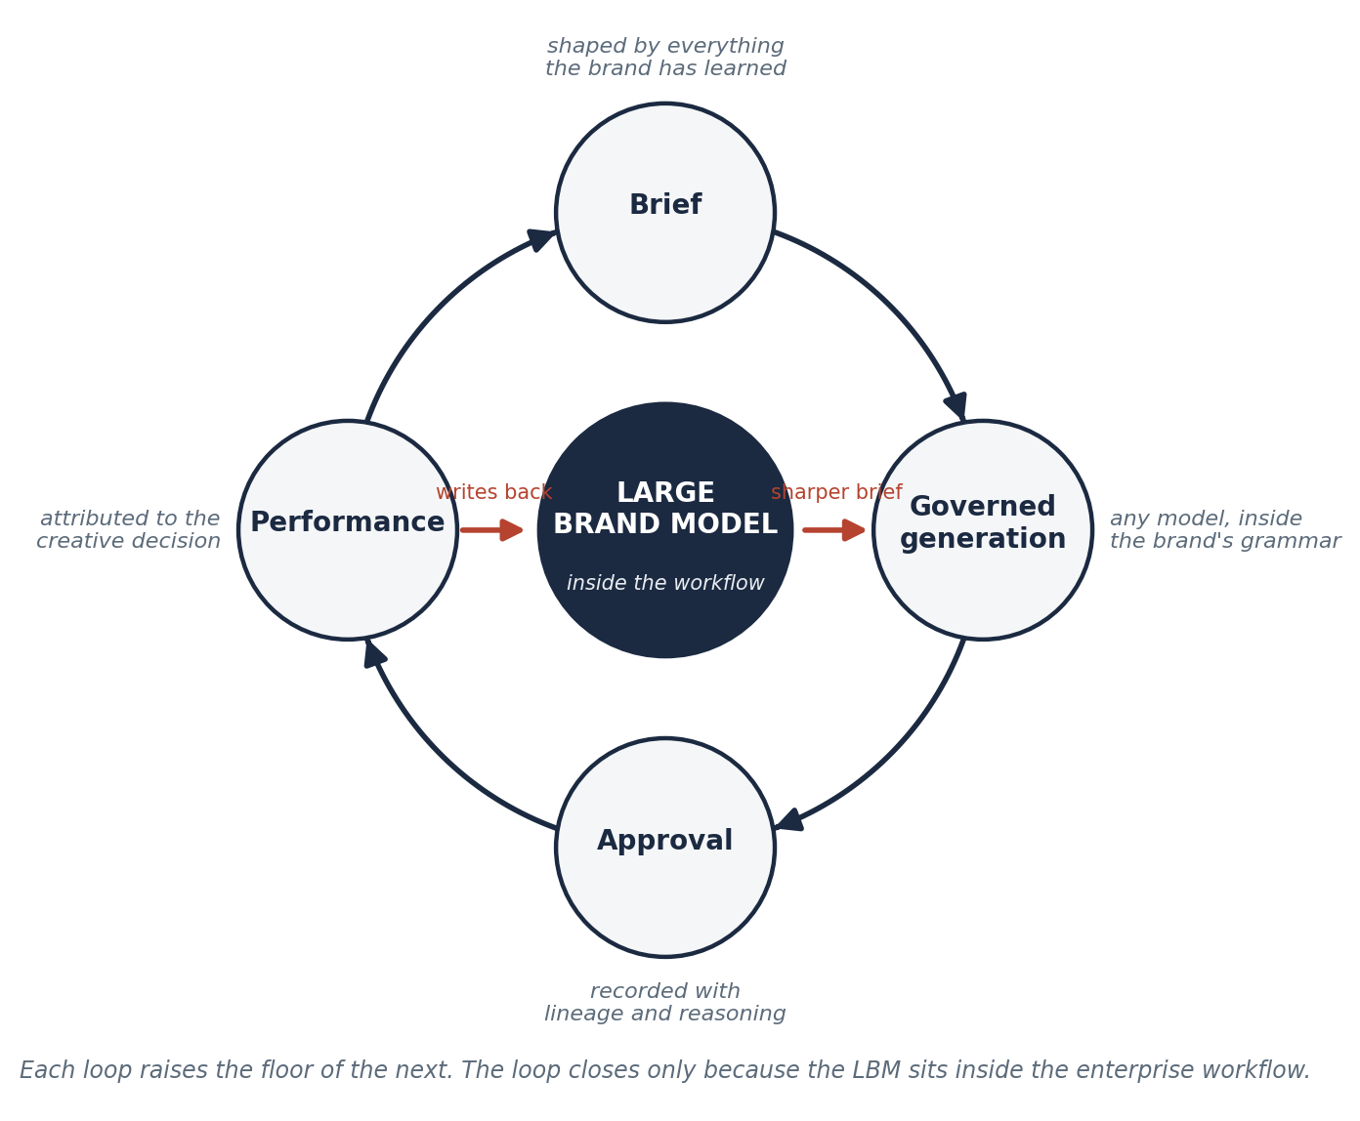
Figure 3. The Large Brand Model flywheel. Each campaign passes through brief, governed generation, approval, and performance. The performance record is written back into the brand knowledge and cinematic grammar layers, so the next brief begins with more than the last one did. The loop closes only because the LBM sits inside the workflow.
Performance data is not defensible in itself. Media platforms have it. Measurement vendors have it. What makes it valuable inside an LBM is where the data lands: inside the same system that wrote the brief, governed the generation, and recorded the approval. Only there can a result be attributed to a creative decision, and only there can the attribution change the next decision automatically. A generation model receives a prompt and returns an asset. It never sees the brief's history, the approval, the media plan, or the result. It sits at one point in the chain and has no visibility into the rest.
The evidence that this loop pays is strong and predates AI. Kantar's matched analysis of roughly 450 ads across its creative database and the WARC ROI database found that the most creative and effective ads generate more than four times as much profit.⁴³ The IPA and System1 named the cumulative effect of consistent creative "compound creativity," and found that the most consistent brands' creative quality scores rise measurably each year.¹¹ Peer-reviewed work adds a caveat worth respecting: Becker and Gijsenberg, writing in the International Journal of Research in Marketing, found that consistency in advertising content drives long-term cumulative sales, with the largest gains for smaller brands and diminishing returns for the largest,⁴⁴ which argues for an intelligence that knows when to hold the line and when to vary, and that learns the difference from results.
Performance data is defensible only where it lands. Inside the system that wrote the brief, it becomes judgment. Anywhere else, it is a report.
The flywheel has one more property worth naming. It gets more valuable as the brand's own archive grows, and the archive belongs to the brand. A brand that has run a hundred governed campaigns through its LBM has a hundred campaigns' worth of attributed learning that no competitor and no vendor can reproduce. Today that asset is scattered across decks and drives and the memories of people who have since changed jobs.

7. What It Changes for CMOs
Governed, repeatable, measurable. Those three words describe what changes when a brand operates through a Large Brand Model, and they map directly onto the pressures CMOs already report. The most recent CMO Survey from Duke University finds that AI now runs a rapidly growing share of marketing activity, that more than 70 percent of marketers prioritize immediate results over long-term gains, and that no marketing technology capability scores above five on a seven-point performance scale.⁴⁵ Technology has outrun the operating model. The LBM is an operating model.

What changes in the workflow
The brief changes first. Today a brief is a document that a team interprets. Under an LBM, the brief is an input to a system that already knows the brand's constraints and history, and the first round of candidates arrives already inside the brand's grammar. Review shifts from catching errors to making choices.
Approval changes second. Approval becomes an event that the system records, with lineage, rather than an email that the system loses. When a regulator, a partner, or a board member asks who approved something, the answer is a query rather than an investigation.
Measurement changes third. Performance data returns to the system that made the creative decisions, and the attribution is at the level of the decision rather than the campaign. That knowledge is retained and applied. It does not leave with the agency or the analyst.

What the CMO keeps control of
Everything that matters. Humans set the rules. Humans approve. Humans direct the creative ambition, an approach Coca-Cola's head of generative AI described when he said creative direction and thought leadership remain human-led, with AI applied to execution and production.⁴⁶ The LBM enforces what humans have decided and remembers what they have approved. It does not decide for them. The CMO also keeps ownership of the accumulated learning: the brand knowledge, the approval history, and the performance record persist when a generation model is retired, when an agency is changed, and when a team member leaves.

What the CMO stops paying for
Rework driven by inconsistency. Lucidpress's survey of more than 200 organizations found that 81 percent still deal with off-brand content and that consistent branding is associated with revenue increases of up to a third, a figure that should be read as self-reported but that points in a direction the IPA's independent data confirms.⁴⁷¹¹ Re-briefing every new vendor and every new model from scratch. Governance that lives in people's heads, which is paid for in incidents. Measurement that cannot reach back to the creative decision, which is paid for in budgets that cannot be defended. And the recurring cost of rebuilding brand intelligence every time the model underneath it is deprecated.
When a regulator, a partner, or a board member asks who approved something, the answer should be a query rather than an investigation.

8. Why This Layer Matters Strategically
Generation is commoditizing. Enterprise creative operations are not.
When the ability to produce a beautiful frame becomes available to everyone at a price near zero, the ability to produce a beautiful frame is not where value accrues. Value accrues to everything that must be true around that frame for a large organization to put its name on it and pay to place it in front of the public. That "everything" is enterprise creative operations, and it has none of the properties of a commodity. It is specific to each brand. It accumulates over time. It is embedded in workflows, approvals, legal review, agency relationships, media plans, and measurement systems that took years to build and cannot be swapped out with an API key.
Two features of the market make this layer durable. The first is the adoption gap. BCG's 2026 survey of 300 CMOs found that 96 percent believe AI is driving end-to-end transformation of the marketing function, while 42 percent use generative AI only to assist humans with individual tasks and 8 percent run campaigns with multiple autonomous agents.⁴⁸ Gartner's 2026 CMO Spend Survey found that CMOs now allocate 15.3 percent of their marketing budgets to AI, and that only 30 percent report mature capabilities to scale it.² McKinsey's 2026 global survey found that 88 percent of organizations use AI regularly in at least one function while only 37 percent report any earnings impact.⁴⁹ The money is committed. The operational capability to spend it well is missing.
The second is the trust gap. Gartner's consumer research found that half of consumers prefer to give their business to brands that avoid generative AI in consumer-facing content, and 68 percent frequently wonder whether what they see is real.⁵⁰ Gallup found in 2026 that 49 percent of Americans view business use of AI in advertising negatively, against 19 percent who view it positively.⁵¹ The IAB found that 82 percent of advertising executives believe younger consumers feel positively about AI-generated ads, while 45 percent of those consumers actually do.⁵² Trust cannot be generated. It is earned through consistency, disclosure, and craft, all of which are governance functions. Yahoo and Publicis found that a noticed AI disclosure produced a 73 percent lift in ad trustworthiness and a 96 percent lift in overall trust for the company.⁵³ Governance is not the tax on AI creative. It is the source of its value.
When a beautiful frame costs nothing, a beautiful frame is not where value accrues. Value accrues to everything that must be true around it before a brand will put its name on it.
Together, these two gaps describe a market in which the scarce capability is the ability to run AI creative inside the enterprise safely, consistently, and provably. That capability is operational. It is learned from inside the workflow. It cannot be downloaded, and it cannot be supplied by a vendor whose product ends at the moment of generation. Value in a commoditizing layer migrates to whoever controls the interface between the commodity and the customer. In commercial creative, that interface is the brand's own intelligence.

9. Conclusion: The Category Has a Name
AI made creative abundant. Abundance doesn't raise the value of making things. It raises the value of controlling them.
For most of the history of advertising, the constraint was production. Ideas were cheap and execution was dear. A brand was defined by what it could afford to make, and the craft of making was where the money and the prestige went. That era ended within the last 24 months. The machines now make. They make endlessly, beautifully, and indifferently, for any brand and no brand, at a cost approaching nothing.
What they cannot do is know. They do not know which of the ten thousand frames belongs to this brand and which merely resembles it. They do not know who approved the last one or why the one before it was refused. They do not know that the spot with the slow reveal outperformed the spot with the fast cut, and that the difference was worth more than the media budget. They do not remember. They are replaced.
The knowing has to live somewhere. It has to persist when the model beneath it is retired. It has to be owned by the brand rather than rented from a vendor. It has to be specific in a way that no general model can be, and it has to grow with every campaign instead of resetting with every release. It has to sit above the models and govern them.
That is a Large Brand Model. Large language models understand language. A Large Brand Model understands one brand: its voice, its visual grammar, its story world, its approval history, and its performance record. It is model-agnostic by design. It is governed, repeatable, and measurable. It is the first piece of infrastructure in the age of abundant creative that makes the abundance safe to use.
The machines now make. What they cannot do is know. The knowing has to live somewhere, and it has to belong to the brand.
Every brand will need its own intelligence. Some will build it. Most will not know they need it until an ungoverned asset carries their name somewhere they did not choose. The brands that move first will compound. The rest will be prompting.
The category has a name. The work begins now.

Putting the Architecture into Practice
Ritual Ads is applying the Large Brand Model architecture to cinematic commercial creative through Ritual Engine. Ritual Engine is Ritual Ads' implementation of the Large Brand Model architecture for cinematic commercial creative: a persistent, model-agnostic intelligence that encodes a brand's voice, visual grammar, story world, approval history, and performance record, and uses that knowledge to direct, constrain, and evaluate the generation models producing work on the brand's behalf.
The implementation begins with motion for the reasons Section 5 describes. Film is the hardest case and the most valuable, and a system that can hold a brand steady across every frame of a story can hold it steady anywhere. Stills, key art, and cutdowns are produced from the same governed intelligence. Brands, agencies, and production partners plug in whatever generation models they choose, and Ritual Engine governs the process around them, from brief to performance.
The operating principle is the discipline the category requires. AI-assisted, human-directed, brand-controlled.

Glossary
Large Brand Model (LBM). A persistent, governed intelligence built around a single brand that encodes the brand's identity, cinematic grammar, approval history, and performance record, and that directs, constrains, and evaluates any generation model producing creative on the brand's behalf. Model-agnostic by design. Its output is a decision rather than an asset.
Brand knowledge layer. The LBM layer that holds identity: voice, visual grammar, story world, distinctive assets, and the meaning and history behind them.
Cinematic grammar layer. The LBM layer that holds craft in motion: shot language, pacing, lighting, sound, transitions, and continuity rules specific to the brand.
Governance and approval layer. The LBM layer that records lineage for every asset, enforces rules at generation time, and makes every approval auditable.
Performance feedback layer. The LBM layer that connects each asset to its results in market and writes what it learns back into the other layers.
Generation model. A foundation model that produces images, video, audio, or text from an input. Generation models sit beneath an LBM and are treated as interchangeable.
Foundation model. A term introduced by Stanford's Center for Research on Foundation Models in 2021 for models trained on broad data at scale and adaptable to a wide range of downstream tasks.
Model-agnostic. An architecture in which the brand's intelligence is independent of any single generation model and can route work to any model without loss of knowledge.
Brief to performance. The span of the creative workflow that an LBM governs, from the initial brief through generation, approval, and distribution to measured results.
The flywheel. The loop by which every campaign's performance data returns to the LBM and sharpens the next brief.
Compound creativity. The finding, from the IPA and System1's study of more than 4,000 ads, that creative consistency produces cumulative brand and business effects over time.
Distinctive brand assets. Elements such as colors, characters, sounds, and shapes that trigger a brand in memory; a concept developed at the Ehrenberg-Bass Institute.
Lineage. The recorded history of an asset: the brief, model, reviewers, changes, rules, and approvals that produced it.
Ritual Engine. Ritual Ads' implementation of the Large Brand Model architecture for cinematic commercial creative.

Notes
Sources are numbered in order of first citation. Each was retrieved and verified between September 1 and September 5, 2026. Where a figure is self-reported by a vendor or trade body, the text says so.
1. IAB (Interactive Advertising Bureau). "Nearly 90% of Advertisers Will Use Gen AI to Build Video Ads, According to IAB's 2025 Video Ad Spend & Strategy Full Report." IAB Newsroom, July 15, 2025. https://www.iab.com/news/nearly-90-of-advertisers-will-use-gen-ai-to-build-video-ads/
2. Gartner. "Gartner 2026 CMO Spend Survey Finds CMOs Allocate 15.3% of Marketing Budgets to AI, But Only 30% Are Ready to Scale AI Capabilities." Gartner Newsroom, May 11, 2026. https://www.gartner.com/en/newsroom/press-releases/2026-05-11-gartner-2026-cmo-spend-survey-finds-cmos-allocate-15-point-3-percent-of-marketing-budgets-to-ai-but-only-30-percent-are-ready-to-scale-ai-capabilities
3. IAB. "AI Adoption Is Surging in Advertising, but Is the Industry Prepared for Responsible AI?" IAB Insights, August 21, 2025. https://www.iab.com/insights/ai-adoption-is-surging-in-advertising-but-is-the-industry-prepared-for-responsible-ai/
4. Jennifer Li and Justine Moore. "The State of Generative Media 2026." Andreessen Horowitz, February 19, 2026. https://a16z.com/the-state-of-generative-media-2026/
5. Susan Li (CFO, Meta Platforms). "Meta (META) Q1 2026 Earnings Call Transcript." The Motley Fool, April 29, 2026. https://www.fool.com/earnings/call-transcripts/2026/04/29/meta-meta-q1-2026-earnings-call-transcript/
6. EMARKETER. "AI-Powered Ad Spend Will Hit $57 Billion in 2026 as Brands Go All In." EMARKETER, April 2, 2026. https://www.emarketer.com/content/ai-powered-ad-spend-will-hit--57-billion-2026-brands-go-all-in
7. Midjourney. "Introducing Our V1 Video Model." Midjourney Updates, June 18, 2025. https://updates.midjourney.com/introducing-our-v1-video-model/
8. John-Anthony Disotto. "Coca-Cola's Iconic 'Holidays Are Coming' Ad Is Now a Soulless and Creepy Dystopian Nightmare Made by AI." TechRadar, November 15, 2024. https://www.techradar.com/computing/artificial-intelligence/coca-colas-iconic-holidays-are-coming-ad-is-now-a-soulless-and-creepy-dystopian-nightmare-made-by-ai
9. Amy Houston. "McDonald's Axed Christmas Ad Tests Audience Threshold for 'AI Slop.'" The Drum, December 11, 2025. https://www.thedrum.com/news/the-most-terrible-ad-of-the-year-mcdonald-s-pulls-ai-ad
10. Alex Weprin. "Google Pulls 'Dear Sydney' Gemini AI Ad From Olympics Coverage After Controversy." The Hollywood Reporter, August 2, 2024. https://www.hollywoodreporter.com/business/digital/google-pulls-dear-sydney-gemini-ai-ad-olympics-1235965087/
11. IPA. "How Creative Consistency Strengthens Brands and Business Effects." IPA News, October 9, 2024. https://ipa.co.uk/news/creative-consistency
12. System1 Group. "Brand Consistency: A New Holistic View on Creativity With IPA and System1" (Compound Creativity). System1, December 2024. https://system1group.com/brand-consistency-compound-creativity
13. Christine Moorman. "Marketing's Strategic Influence Expands, As Does Scrutiny." The CMO Survey (34th edition), Duke University Fuqua School of Business, Spring 2025. https://www.fuqua.duke.edu/duke-fuqua-insights/marketing-strategic-influence-expands-as-does-scrutiny
14. NCSolutions. "Five Keys to Advertising Effectiveness" (2023 update). NCSolutions, August 2023. https://info.ncsolutions.com/hubfs/2023%20Five%20Keys%20to%20Advertising%20Effectiveness/NCS_Five_Keys_to_Advertising_Effectiveness_E-Book_08-23.pdf
15. Westwood One. "Marketers Vastly Understate the Sales Effect of Creative and Significantly Overestimate the Impact of Targeting." Westwood One Blog, April 22, 2024. https://www.westwoodone.com/blog/2024/04/22/marketers-vastly-understate-the-sales-effect-of-creative-and-significantly-overestimate-the-impact-of-targeting/
16. CDP Institute. "The CDP Institute Backstory." CDP Institute, accessed September 5, 2026. https://www.cdpinstitute.org/about/
17. Scott Brinker. "The 2010 Marketing Technology Proto-Landscape Did Consolidate by 61%." chiefmartec.com, October 2017. https://chiefmartec.com/2017/10/early-marketing-technology-landscape-consolidated/
18. Scott Brinker. "2025 Marketing Technology Landscape Supergraphic: 100X Growth Since 2011, But Now With AI." chiefmartec.com, May 6, 2025. https://chiefmartec.com/2025/05/2025-marketing-technology-landscape-supergraphic-100x-growth-since-2011-but-now-with-ai/
19. Rishi Bommasani et al. "On the Opportunities and Risks of Foundation Models." Stanford Center for Research on Foundation Models, arXiv:2108.07258, August 16, 2021. https://arxiv.org/abs/2108.07258
20. Patrick Lewis et al. "Retrieval-Augmented Generation for Knowledge-Intensive NLP Tasks." arXiv:2005.11401, May 22, 2020. https://arxiv.org/abs/2005.11401
21. Salesforce. "75% of Marketers Have Adopted AI Yet Still Use It to Send One-Way, Generic Campaigns." Salesforce Newsroom (State of Marketing, 10th edition), February 19, 2026. https://www.salesforce.com/news/stories/state-of-marketing-2026/
22. OpenAI. "Sora Is Here." OpenAI, December 9, 2024. https://openai.com/index/sora-is-here/
23. OpenAI. "Sora 2 Is Here." OpenAI, September 30, 2025. https://openai.com/index/sora-2/
24. OpenAI. "What to Know About the Sora Discontinuation." OpenAI Help Center, 2026. https://help.openai.com/en/articles/20001152-what-to-know-about-the-sora-discontinuation
25. Connie Loizos. "Why OpenAI Really Shut Down Sora." TechCrunch, March 29, 2026. https://techcrunch.com/2026/03/29/why-openai-really-shut-down-sora/
26. Google. "State-of-the-Art Video and Image Generation With Veo 2 and Imagen 3." Google Blog (Google Labs), December 16, 2024. https://blog.google/technology/google-labs/video-image-generation-update-december-2024/
27. Google. "Fuel Your Creativity With New Generative Media Models and Tools." Google Blog, May 20, 2025. https://blog.google/technology/ai/generative-media-models-io-2025/
28. Google. "Bringing New Veo 3.1 Updates Into Flow to Edit AI Video." Google Blog, October 15, 2025. https://blog.google/innovation-and-ai/products/veo-updates-flow/
29. Kyle Wiggers. "Runway Releases an Impressive New Video-Generating AI Model." TechCrunch, March 31, 2025. https://techcrunch.com/2025/03/31/runway-releases-an-impressive-new-video-generating-ai-model
30. Kezia Jungco. "Runway Launches Gen-4.5 AI Video Model." eWeek, December 2, 2025. https://www.eweek.com/news/runway-ai-video-model/
31. Kuaishou Technology. "Kling AI Celebrates First Anniversary; Achieves Annualized Revenue Run Rate Surpassing USD100 Million in 10th Month Since Launch." Kuaishou Investor Relations, June 5, 2025. https://ir.kuaishou.com/news-releases/news-release-details/kling-ai-celebrates-first-anniversary-achieves-annualized/
32. Kuaishou Technology. "Kling AI Launches 3.0 Model, Ushering in an Era Where Everyone Can Be a Storyteller." Kuaishou Investor Relations, February 5, 2026. https://ir.kuaishou.com/news-releases/news-release-details/kling-ai-launches-30-model-ushering-era-where-everyone-can-be
33. OpenAI. "Introducing 4o Image Generation." OpenAI, March 25, 2025. https://openai.com/index/introducing-4o-image-generation/
34. OpenAI. "The New ChatGPT Images Is Here." OpenAI, December 16, 2025. https://openai.com/index/new-chatgpt-images-is-here/
35. Google. "Introducing Gemini 2.5 Flash Image, Our State-of-the-Art Image Model." Google Developers Blog, August 26, 2025. https://developers.googleblog.com/en/introducing-gemini-2-5-flash-image/
36. Google. "Nano Banana Pro: Gemini 3 Pro Image Model From Google DeepMind." Google Blog, November 20, 2025. https://blog.google/innovation-and-ai/products/nano-banana-pro/
37. OpenAI. "Deprecations." OpenAI API Documentation, accessed September 5, 2026. https://developers.openai.com/api/docs/deprecations
38. Microsoft. "Foundry Models Lifecycle and Support Policy." Microsoft Learn, updated July 24, 2026. https://learn.microsoft.com/en-us/azure/foundry/openai/concepts/model-retirements
39. Jenni Romaniuk. Building Distinctive Brand Assets. Oxford University Press, May 16, 2018. https://global.oup.com/academic/product/building-distinctive-brand-assets-9780190311506
40. Dom Boyd. "Think Different: The DNA of Breakthrough Brand Value Growth." Kantar, July 14, 2023. https://www.kantar.com/inspiration/advertising-media/think-different-the-dna-of-breakthrough-brand-value-growth
41. Alison Hoad. "The Next Chapter for 'The Long and The Short of It.'" IPA Blog, September 13, 2023. https://ipa.co.uk/knowledge/ipa-blog/the-next-chapter-for-the-long-and-the-short-of-it
42. Ecem Erdem and Věra Šídlová. "Rethinking AI-Generated Advertising: How Real People Really React." Kantar, November 4, 2025. https://www.kantar.com/inspiration/advertising-media/rethinking-ai-generated-advertising
43. Polly Wyn Jones. "The Art of Proof: How Creative Quality Drives Profit." Kantar, February 9, 2023. https://www.kantar.com/inspiration/advertising-media/the-art-of-proof-how-creative-quality-drives-profit
44. Maren Becker and Maarten J. Gijsenberg. "Consistency and Commonality in Advertising Content: Helping or Hurting?" International Journal of Research in Marketing, Vol. 40, Issue 1, 2023, pp. 128–145. https://research.rug.nl/en/publications/consistency-and-commonality-in-advertising-content-helping-or-hur/
45. Christine Moorman. "CMOs Face Headwinds Even as Marketing Value and AI Impact Grow." The CMO Survey (35th edition), Duke University Fuqua School of Business, Spring 2026. https://www.fuqua.duke.edu/duke-fuqua-insights/CMOs-Face-Headwinds-Even-as-Marketing-Value-and-AI-impact-grow
46. The Coca-Cola Company. "Coca-Cola Refreshes Givers of the Season, Embraces AI-Powered Storytelling in Global Holiday Campaign." Coca-Cola Media Center, November 3, 2025. https://www.coca-colacompany.com/media-center/coca-cola-refreshes-givers-of-the-season-embraces-ai-powered-storytelling-in-global-holiday-campaign
47. Lucidpress (now Marq). "Study Finds Companies With Consistent Branding Can See Up to 33% Increase in Revenue." PR Newswire, December 2, 2019. https://www.prnewswire.com/news-releases/study-finds-companies-with-consistent-branding-can-see-up-to-33-increase-in-revenue-300967219.html
48. Boston Consulting Group. "Mind the Marketing Gap: Most CMOs Say AI Is Transforming Marketing, But Few Are Using It to Transform Their Own Function." BCG Press Release, June 15, 2026. https://www.bcg.com/press/15june2026-cmos-ai-transforming-marketing-transform-function
49. McKinsey & Company (QuantumBlack). "The State of AI: Global Survey 2026." McKinsey, August 25, 2026. https://www.mckinsey.com/capabilities/quantumblack/our-insights/the-state-of-ai
50. Gartner. "Gartner Marketing Survey Finds 50% of Consumers Prefer Brands That Avoid Using GenAI in Consumer-Facing Content." Gartner Newsroom, March 16, 2026. https://www.gartner.com/en/newsroom/press-releases/2026-03-16-gartner-marketing-survey-finds-50-percent-of-consumers-prefer-brands-that-avoid-using-genai-in-consumer-facing-content0
51. Julie Ray. "Americans Aren't Sold on Businesses Using AI in Advertising." Gallup, August 19, 2026. https://news.gallup.com/poll/713222/americans-aren-sold-businesses-using-advertising.aspx
52. Debra Aho Williamson, Jack Koch, and Caroline Gigerich. "The AI Ad Gap Widens." IAB Insights, January 15, 2026. https://www.iab.com/insights/the-ai-gap-widens/
53. Yahoo Inc. "Yahoo & Publicis Media Survey Reveals AI Ad Disclosure Increases Consumer Trust." Yahoo Inc. Press Release, February 28, 2024. https://www.yahooinc.com/press/yahoo-publicis-media-survey-reveals-ai-ad-disclosure-increases-consumer-trust

About Ritual Ads
Ritual Ads is a cinematic intelligence studio, powered by Ritual Engine.
Ritual Ads is the operating and decision layer for enterprise commercial creative. One governed system carries a campaign from brief to performance, across any AI model. Ritual Engine, the intelligence at the center of that system, is Ritual Ads' implementation of the Large Brand Model architecture for cinematic commercial creative.
The company was founded by Jethro Rothe-Kushel, a 25-year veteran of cinematic production who served as a national board member and vice president of the Producers Guild of America. His career spans technology, production, and marketing, including work with Apple, Netflix, and American Express, and began in 1999 as a presidential research scholar in artificial intelligence and video sciences at Dartmouth College.
Ritual Ads is headquartered in Beverly Hills, California.
AI-assisted, human-directed, brand-controlled.

