A RITUAL ADS WHITE PAPER
The RITUAL Protocol
The Open Record Beneath Every Generated Story

Jethro Rothe-Kushel
Founder and Chief Executive Officer, Ritual Ads, Inc.
September 2026
Rights, Intent, Trace, Use, Attribution, Learning. Six fields that travel with every story. Any model can make the story. Only the record makes it trustworthy.
Ritual Ads is a cinematic intelligence studio, powered by Ritual Engine.

Executive Summary
Two protocols were born in 1974. In May, Vinton Cerf and Robert Kahn published the paper that described how dissimilar packet networks could be joined into "a network of networks."¹² In June, a pack of chewing gum carrying a Universal Product Code was scanned at a supermarket in Troy, Ohio.³ Neither was a product. Each was an agreement about what travels with a thing so that any system can trust it. One became the internet. The other is scanned more than six billion times a day by more than two million companies.³
Generative AI has made stories abundant in every industry that runs on them. Advertising, cinema, and medicine now share a condition: anyone can produce a convincing moving image, and no institution holds the record of where it came from, who consented to it, what it is allowed to claim, and what it did to the person who watched it. The costs are already measured. When the programmatic advertising supply chain had no shared record, 15 percent of spend could not be traced at all; when the industry standardized its data, the unknown fell to 3 percent.⁴ The FDA is sending warning letters in the thousands over drug promotion that states benefits without harms.⁵ The European Union has required, since August 2, 2026, that synthetic content be "marked in a machine-readable format,"⁶ and California fines $5,000 per violation per day for the same failure.⁷
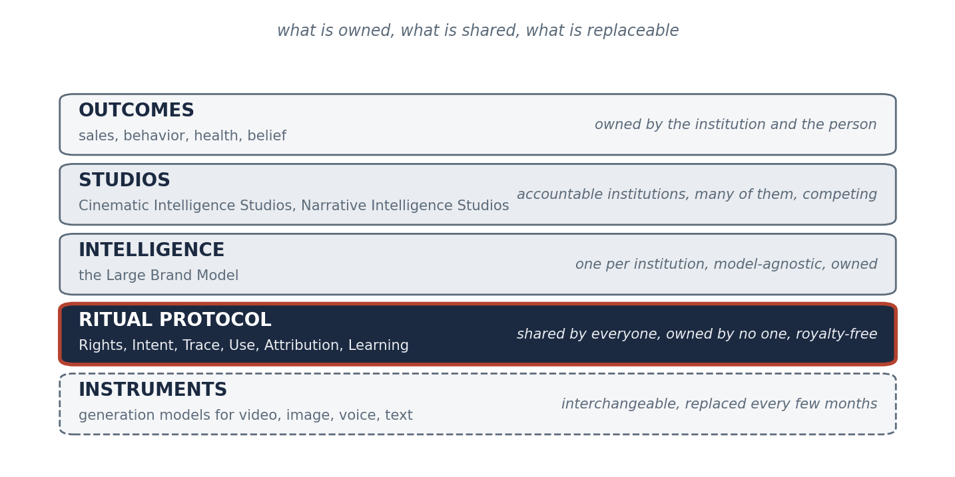
Figure A. The RITUAL Protocol in one view. Six primitives travel with every generated story, from the brief that opened it to the outcome that closed it. Any generation model can produce the work. Any institution can own the intelligence. The protocol is what they share.
This paper defines the layer that is missing. The RITUAL Protocol is an open, royalty-free specification for what must travel with a generated story: Rights, Intent, Trace, Use, Attribution, and Learning. It is the record beneath the three institutions Ritual Ads has defined in companion papers: the Large Brand Model, the persistent intelligence a brand owns; the Cinematic Intelligence Studio, the institution that makes commercial creative through that intelligence; and the Narrative Intelligence Studio, the same institution built for health outcomes. Each of those is a layer that one organization owns. The protocol is the layer that all of them, and their competitors, share. Model-agnostic by design. Industry-agnostic by construction. Governed the way TCP, the barcode, and the web were governed: openly, so that the value accrues to whoever builds the best thing on top.
AI made creative abundant. Abundance doesn't raise the value of making things. It raises the value of controlling them. A protocol is how control becomes ubiquitous.
Contents

1. The Problem: Four Industries, One Missing Layer
Every industry that moves people with moving images has just lost the scarcity that organized it. Nearly 90 percent of advertisers say they will use generative AI to build video ads.⁸ A national television spot was produced with a video model for about $2,000.⁹ Netflix has put generated footage inside a finished original,¹⁰ Amazon MGM has greenlit three series on a generative production platform,¹¹ and 23 percent of the ads in the most-watched broadcast of the year used AI.¹² In medicine, 63 percent of Americans consider AI-generated health information reliable,¹³ and the stories they receive are made by the same tools, with the same absence of a record.
The absence has a shape. In advertising, three institutions hold pieces: the agency holds the idea, the production company holds the craft, the tool vendor holds the generator, and none is accountable for what the work did. In entertainment, the studio that licensed 200 characters to a video product watched the product be discontinued three months later, and the record of what was generated under that license lives nowhere in particular.¹⁴¹⁵ In health, medicine holds the science and has cut the story, health marketing holds the story and is regulated for good reason, and the app holds the data and loses 97 percent of its users by day thirty.¹⁶ Across all three, the question a regulator, a court, a patient, or a chief marketing officer will ask is the same: where did this come from, who agreed to it, what was it allowed to say, and what happened next?
Today that question is answered by email threads, vendor dashboards, and memory. The advertising industry has already paid to learn what that costs. In 2020, a forensic audit of the programmatic supply chain found that only 51 percent of advertiser spend reached publishers and that 15 percent could not be attributed to anyone. Three years later, after the industry standardized its data and its audit toolkit, the unknown had fallen to 3 percent and impression matching had risen from 12 to 58 percent.⁴ Nothing about the technology changed. The record did.
Nothing about the technology changed. The record did.
The regulators have stopped waiting. The EU AI Act's transparency obligations took effect on August 2, 2026, requiring that synthetic content be "appropriately marked in a machine-readable format" and that deepfakes be disclosed.⁶¹⁷ California's AI Transparency Act became operative the same day, requiring covered providers to embed latent provenance disclosures, requiring large platforms from 2027 to detect and preserve them and "not knowingly strip compliant provenance data," and treating each day of violation as a discrete $5,000 offense.⁷ The FTC's 2024 rule bans testimonials that misrepresent a real person's experience, AI-generated ones included.¹⁸ The HIPAA Privacy Rule requires written authorization before a patient's information is used for marketing.¹⁹ The 2025 SAG-AFTRA commercials contract requires consent before a performer's likeness or voice is synthesized.²⁰ Each of these is a requirement that something travel with the story. None of them says what, or in what form. That is the definition of a missing protocol.

2. What a Protocol Is, and Why 1974 Matters
A protocol is an agreement about what travels with a thing. It is smaller than a product, which is why it outlasts products, and it is stricter than a convention, which is why strangers can rely on it. TCP did not build the internet. It specified what a packet had to carry so that any network could hand it to any other, and the networks built themselves.¹ The barcode did not build retail. It specified twelve digits that any scanner could read, and within fifty years more than two million companies in 150 countries were relying on it, six billion times a day.³
The economics of protocols are well understood and frequently forgotten. Joel Monegro's observation about the internet is the clearest statement of it: "The previous generation of shared protocols (TCP/IP, HTTP, SMTP, etc.) produced immeasurable amounts of value, but most of it got captured and re-aggregated on top at the applications layer, largely in the form of data."²¹ Thin protocols, fat applications. The protocol does not capture the value. It creates the conditions under which the value can be captured by whoever holds the data and the intelligence on top of it. That is the right outcome. A protocol that tried to own the value would not be adopted.
CERN understood this on April 30, 1993, when it released the World Wide Web "into the public domain, for general use, and at no cost." The W3C's own retrospective explains the consequence: "The open platform of royalty-free standards enabled software companies to profit by selling new products with powerful features, enabled e-commerce companies to profit from services that grew on this foundation, and brought social benefits in the non-commercial realm."²² Berners-Lee's original proposal had already stated the design principle that makes a protocol survive the systems it connects: "the method of storage must not place its own restraints on the information."²³
A protocol does not capture the value. It creates the conditions under which the value can be captured by whoever builds the best thing on top.
The same pattern has repeated in every industry this paper touches. Medicine's imaging standard began in 1983 as a committee of radiologists and equipment makers, published its first point-to-point version in 1985, and became DICOM in 1993;²⁴ today no imaging device is sold without it. Health records followed with FHIR, whose "basic building block" is a Resource, a standardized unit of exchangeable content,²⁵ which the federal government made mandatory for Medicare Advantage, Medicaid, and exchange plans in 2020.²⁶ Cinema's delivery standard, the Interoperable Master Format, was standardized by SMPTE in 2013 and is now specified by Netflix, the BBC, and Disney; its core idea is that every essence of a finished film is stored as a separate track and a composition playlist tells any system how to assemble them.²⁷²⁸ Advertising built OpenRTB in 2010 to let an individual ad impression be bid on in real time,²⁹ then ads.txt in 2017 to let buyers verify sellers; within months, 57 percent of the top thousand programmatic sellers had adopted it.³⁰
And in the twelve months before this paper, the AI industry built its own. The Model Context Protocol, an open standard for connecting models to tools and data, reached 97 million monthly SDK downloads and 10,000 active servers, with client support across ChatGPT, Claude, Cursor, Gemini, and Microsoft Copilot, before being donated to a vendor-neutral foundation under the Linux Foundation, co-founded by Anthropic, Block, and OpenAI with Google, Microsoft, and AWS in support.³¹³² The lesson is exact. Competing model companies adopted a shared protocol because a shared protocol made each of their models more valuable. The value stayed in the models and the applications. The protocol stayed thin.
Provenance is the closest precedent to what this paper proposes, and the most instructive. The C2PA standard for content credentials, a cryptographically signed record of a media file's origin and edits, is now governed by a steering committee of Adobe, Amazon, the BBC, Google, Meta, Microsoft, OpenAI, Publicis Groupe, Sony, TikTok, and Truepic.³³ TikTok joined the committee in July 2026 having already labeled more than three billion pieces of content as AI-generated.³⁴ The Content Authenticity Initiative that promotes the standard passed 6,000 members in January 2026, with credentials now embedded at capture in a Sony video camera and a Google phone.³⁵ Content credentials answer the question of origin. They do not answer the questions of rights, intent, permitted use, outcome, or learning. The RITUAL Protocol is designed to carry a content credential inside it and to answer the rest.

3. Six Words: The RITUAL Primitives
The protocol is named for what it carries. Six primitives, in the order they occur in the life of a story.
Primitive | What it records | The question it answers | The precedent
Rights | Who may be depicted, what may be used, under what consent, license, or authorization, with remuneration disclosed | Who agreed to this? | SAG-AFTRA consent, HIPAA authorization, verifiable credentials
Intent | The brief as a structured object: the audience, the outcome sought, the constraints, the claims permitted | What was this for? | The FHIR Resource, the OpenRTB bid request
Trace | The lineage of every asset: models, prompts, reviewers, changes, refusals, and the content credential | Where did this come from? | C2PA content credentials, IMF composition playlist
Use | The context of use: channel, jurisdiction, audience, disclosure, fair balance, the rules applied at delivery | What was it allowed to be? | Article 50, SB 942, FTC testimonial rule, ads.txt
Attribution | The outcome, bound to the creative decision that produced it | What did it do? | ISBA log-level audit, clinical endpoint
Learning | The write-back into a persistent, model-agnostic intelligence owned by the institution | What does the next one begin knowing? | The Large Brand Model

Rights. The word is chosen against "permissions" and "terms." A permission is granted once and forgotten. A right travels. The protocol records, for every person, voice, likeness, mark, and piece of source material in a story, who holds the right, what they consented to, and what they were paid, in a form a third party can verify. The precedent is the W3C's verifiable credential, "a set of claims made by an issuer about a subject,"³⁶ and the requirement is already law in every industry the protocol touches: written HIPAA authorization with remuneration disclosed,¹⁹ union consent before synthesis,²⁰ and no testimonial that misrepresents a real person's experience.¹⁸
Intent. The word is chosen against "brief" and "prompt." A brief is a document. A prompt is a string. Intent is structured: who the story is for, what it is meant to change, what it may claim, and what it must not. In health, intent names the population and the endpoint, because the same survivor-story video that made no overall difference doubled screening among women without a high school diploma.³⁷ In advertising, intent names the brand outcome, because emotional campaigns deliver roughly twice the profit of rational ones and the difference is only visible if someone recorded what the work was trying to do.³⁸
Trace. The word is chosen against "metadata" and "provenance." Metadata describes a file. Provenance describes its origin. Trace describes its life: which models generated which candidates, which were refused and why, who reviewed, what changed, and which consents applied at each step. A content credential is the signed seal on the trace; the trace is the record the seal protects. Cinema already works this way at delivery, where IMF stores every essence as a separate track file and a composition playlist records how they assemble.²⁷ The protocol extends that discipline upstream, to the moment of generation.
Use. The word is chosen against "compliance" and "distribution." Compliance is a department. Use is a field on the record: where the story may run, for whom, with what disclosure, under which jurisdiction's rules, with fair balance where a treatment is discussed. The FDA's draft framework for AI in regulatory decisions supplies the governing phrase: a "risk-based credibility assessment" of a model "for a particular context of use."³⁹ A story that is credible for one context of use is not credible for another, and the protocol records which.
Attribution. The word is chosen against "analytics" and "reporting." Analytics measures the channel. Attribution binds the outcome to the decision. Blood pressure eleven points lower in the patients who watched the stories;⁴⁰ a million quits from a campaign of true stories at $268 per year of healthy life gained;⁴¹⁴² a share point moved by a campaign whose emotional response was scored before it aired.⁴³ Each of these was attributed once, by a study. The protocol attributes every time, by design.
Learning. The word is chosen against "data" and "training." Data accumulates. Training is what a vendor does to a model that will be deprecated. Learning is what the institution keeps: the write-back of every attributed outcome into an intelligence that persists across models, vendors, and staff. This is the Large Brand Model, defined in the companion paper as a persistent, model-agnostic intelligence that encodes a brand's identity, its cinematic grammar, its governance history, and its record of what worked. The protocol is how that intelligence is fed, and how it stays portable.
Rights, Intent, Trace, Use, Attribution, Learning. Six fields that travel with every story. Any model can make the story. Only the record makes it trustworthy.

4. The Record: What Travels With Every Story
The unit of the protocol is the RITUAL record. It is opened when a brief enters a system and closed when an outcome is written back, and it travels with the asset for the asset's life, the way a composition playlist travels with a master and a content credential travels with a file. It is a document, not a database. It can be read by a regulator, a client, a court, a platform, or another studio's intelligence without access to the system that made it.
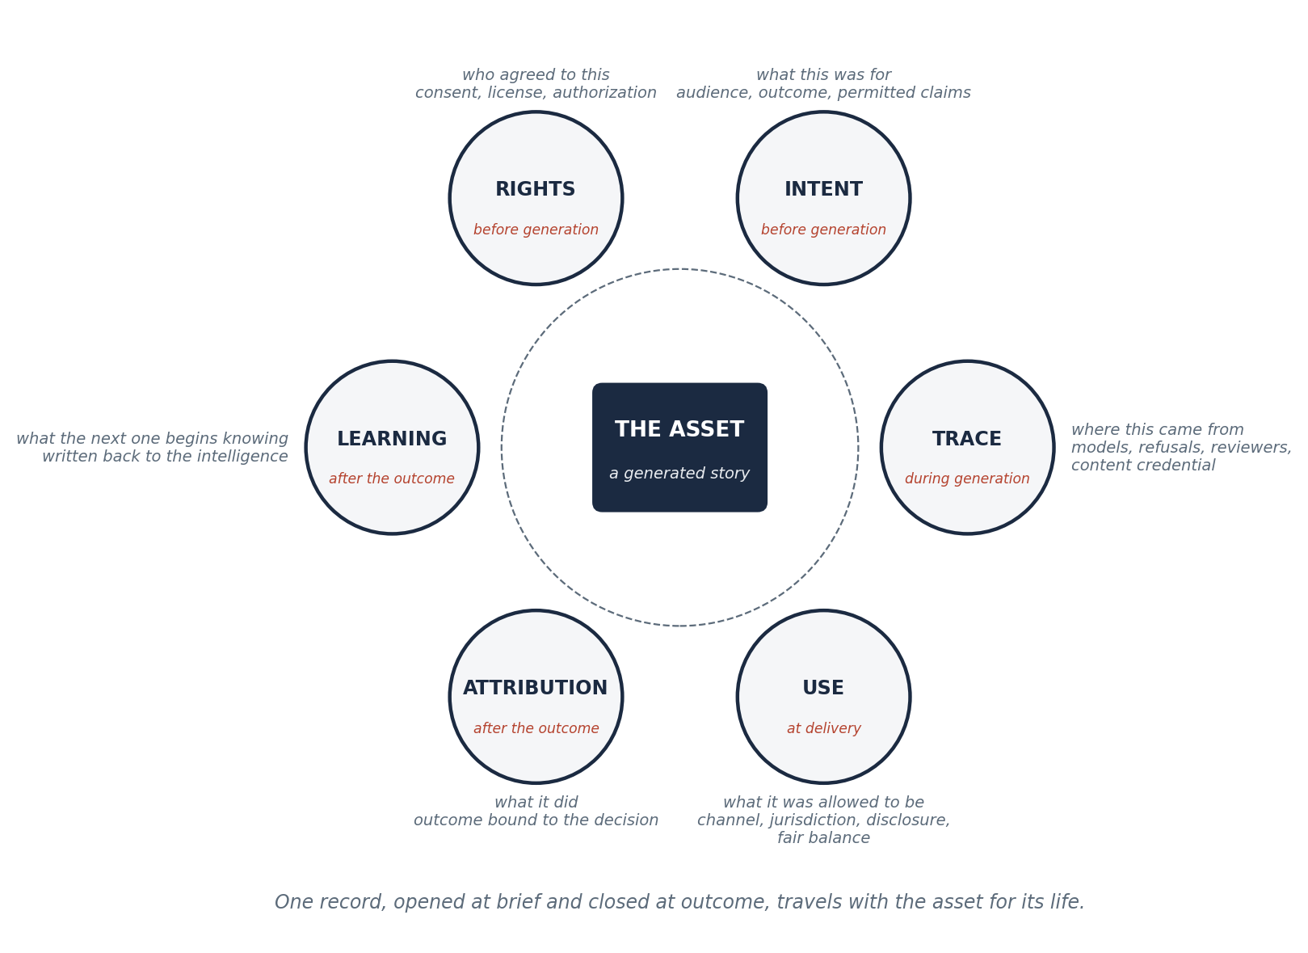
Figure 1. Anatomy of a RITUAL record. Six fields surround the asset. Rights and Intent are written before generation. Trace accumulates during it. Use is confirmed at delivery. Attribution and Learning are written after the outcome. A content credential seals the Trace; the record carries the credential.
A worked example makes the record concrete. A hospital system briefs a story about medication adherence for patients discharged after a cardiac event. The record opens.
Field | Entry
Rights | Patient A, written HIPAA authorization dated and signed, no remuneration; Actor B, union consent for voice synthesis under the 2025 commercials contract, session fee recorded; hospital marks licensed; music licensed for streaming and clinic display
Intent | Population: adults discharged after myocardial infarction, English and Spanish; outcome: 90-day prescription refill rate; claims permitted: adherence benefits per label; claims prohibited: comparative efficacy
Trace | Candidates generated by two video models and one voice model; 14 refused for brand-grammar violations, 3 for medical-review flags; director's cut approved by medical reviewer, legal, and brand; content credential signed at export
Use | Channel: patient portal and discharge tablet; jurisdiction: United States, California; disclosure: AI-assisted, synthetic voice declared; fair balance: side effects presented at equal prominence
Attribution | 90-day refill rate in the exposed cohort against the unexposed cohort, by language, by story variant, with the confidence interval
Learning | Written back: the peer-story opening outperformed the clinician opening for Spanish-speaking patients; the clinician opening outperformed for patients over 70; the refused candidates are cautions in the craft layer

Every entry is a fact someone already needed. What the protocol changes is that they are recorded once, in a shared form, at the moment they occur, rather than reconstructed later from separate systems. The ISBA audit found that when the advertising industry did this for spend, the unknown fell from 15 percent to 3.⁴ The protocol asks the same of stories.
Three properties of the record matter more than its fields. It is portable: a RITUAL record produced by one studio can be read by another, or by the client, or by the platform that must detect and preserve provenance under California law from 2027.⁷ It is minimal: it records what a third party would need to trust the story and nothing about how the studio made it, so that no studio's craft is disclosed by the protocol. And it is layered: the content credential inside the Trace field is a C2PA manifest, unchanged, so that the protocol adds to the provenance standard rather than competing with it.³³
The record is portable, minimal, and layered. It tells a stranger what to trust. It tells nobody how the work was made.

5. The Handshake: Six Checkpoints From Brief to Outcome
A protocol is a record and a handshake. The record says what travels. The handshake says when each field must be present before the next step may proceed. The RITUAL handshake places six checkpoints in the operating model that the companion papers describe, so that governance is a property of the flow rather than a review at the end.
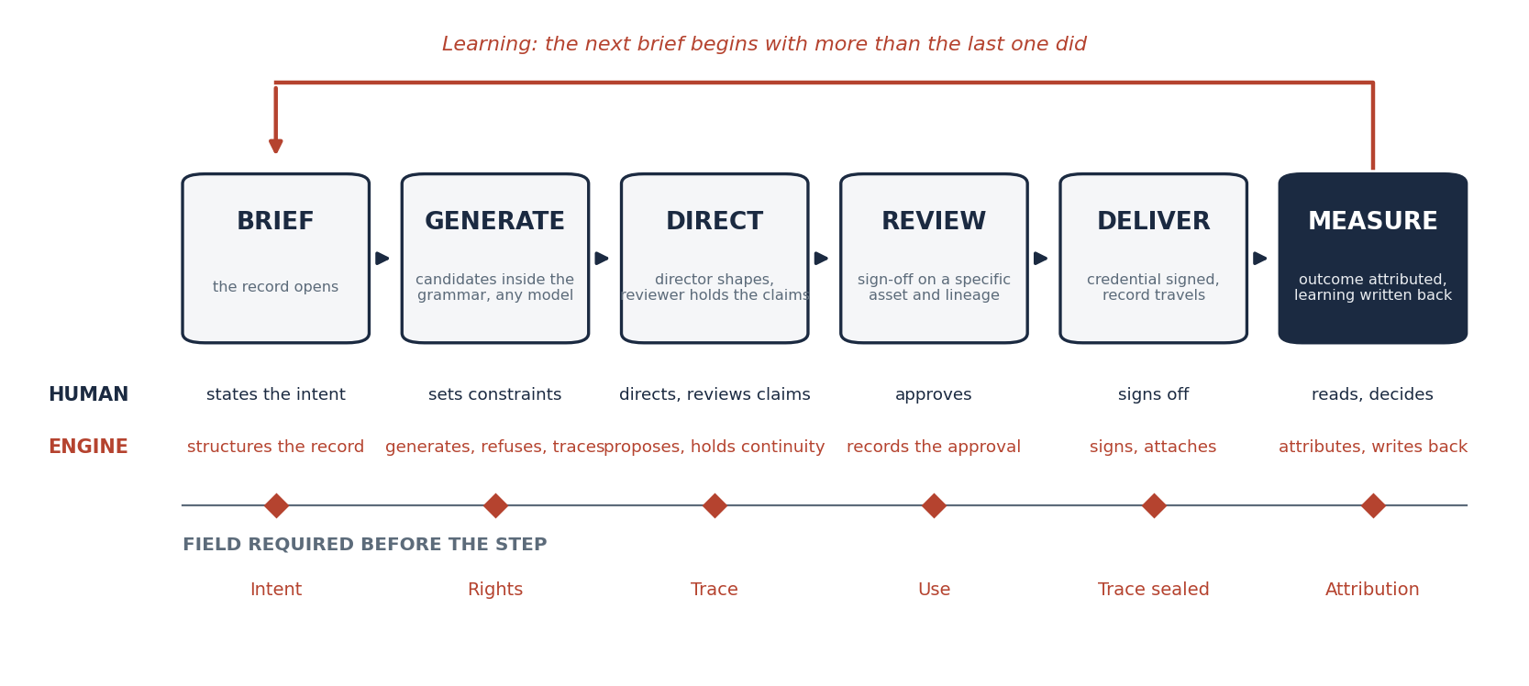
Figure 2. The RITUAL handshake. Six steps, brief to outcome, and the field that must be complete before each step may proceed. Human direction at every creative and clinical decision; machine assistance at every step where assistance is possible; the record written as the work moves.
Brief. The record opens. Intent must be structured before anything is generated: population, outcome, permitted claims, constraints. A brief that cannot state its outcome is not ready for a system that will be held to one.
Generate. Rights must be complete before any real person's likeness, voice, or history is synthesized, and any synthetic person is marked as such from the first candidate. Candidates are generated inside the institution's grammar by whichever models best serve the scene, and refused when they fall outside it. Each candidate, kept or refused, enters the Trace.
Direct. A director shapes the story; a medical or legal reviewer holds the claims; a producer holds the record. Trace accumulates: who changed what, and why. This is the step where human judgment does the work the models cannot, and where the record makes that judgment auditable without making it slower.
Review. Use is confirmed. Legal, medical, and brand sign off on a specific asset with a specific lineage, in a specific context of use, with disclosure decided and recorded. The EU's Article 50 marking requirement and California's latent-disclosure requirement are satisfied here, as fields, before the work ships.⁶⁷
Deliver. The content credential is signed and the record travels with the asset. Platforms that must detect and preserve provenance can read it.⁷ Clients that must show a regulator the fair balance can read it.⁵ A stranger can verify the story without trusting the studio.
Measure. Attribution is written: the outcome, bound to the creative decisions that produced it. Learning is written back into the institution's intelligence. The record closes, and the next brief opens knowing more than the last one did.
The handshake is strict about order and silent about method. It does not say which models to use, how to direct, or what the story should be. It says that Rights precede generation, that Use precedes delivery, and that Attribution precedes Learning. Those three orderings are the whole of its governance, and they are enough. Every regulatory failure in this paper is a violation of one of them: a testimonial synthesized without consent, a promotion delivered without fair balance, a campaign renewed without knowing what the last one did.
Rights before generation. Use before delivery. Attribution before learning. Three orderings, and every failure in this paper is a violation of one of them.

6. The Stack: Instruments, Protocol, Intelligence, Studios, Outcomes
The three companion papers each defined a layer. This paper places them in a stack, because a stack is what protocols make possible: a layer that is shared, with layers above and below it that are owned.
Layer | What it is | Who owns it | Companion paper
Outcomes | Sales, behavior, health, belief: the measured change in a person | The institution and the person | All three
Studios | Accountable institutions that make the work: Cinematic Intelligence Studios for commerce, Narrative Intelligence Studios for health, and others to come | Each studio | CIS, NIS
Intelligence | The Large Brand Model: a persistent, model-agnostic memory of one institution's identity, grammar, governance, and results | The brand or institution | LBM
Protocol | The RITUAL record and handshake: what travels with every story | Nobody; open and royalty-free | This paper
Instruments | Generation models for video, image, voice, and text | The model vendors; replaced every few months | All three

The bottom layer is the one nobody should own. A generation model is a product, and products are retired. The video product that licensed 200 characters from the world's largest entertainment company was discontinued within four months of the deal.¹⁴¹⁵ The leading model changes hands every few months.⁴⁴ Every intelligence that is a fine-tune of a base model dies with the base model. The protocol sits above the instruments so that nothing above it does.
The intelligence layer is the one each institution must own. The companion paper on the Large Brand Model argued that a brand's knowledge of itself exists in no general model and must be held, persistently, somewhere. The protocol is how that intelligence is fed without being exposed. Learning is written back through the record; the intelligence itself never leaves the institution. A hospital's model of its patients and a beverage brand's model of its audience are built on the same six fields and share nothing else.
The studio layer is the one that competes. A Cinematic Intelligence Studio and a Narrative Intelligence Studio are institutions accountable from brief to outcome, and there will be many of them, in many industries, from many companies. They compete on craft, on the quality of their intelligence, and on their results. They do not compete on the record, any more than two hospitals compete on DICOM or two streaming services on IMF. A studio that writes RITUAL records can be audited by its client, trusted by a platform, read by a regulator, and, when the client leaves, hand over a record the next studio can continue. That last property is the one that makes clients willing to commit to a studio at all.
The precedent for this stack is the one the AI industry just built for itself. Competing model companies adopted a shared context protocol because it made each model more useful, then placed it under neutral governance so that no one of them could capture it.³¹ The value stayed where it belonged: in the models below and the applications above. Model-agnostic by design.
Two hospitals do not compete on DICOM. Two streaming services do not compete on IMF. Two studios should not compete on the record.

7. Where It Touches: Advertising, Cinema, Health, and Beyond
A protocol that fits one industry is a format. A protocol that fits several is infrastructure. The six primitives were derived from three industries with different regulators, different outcomes, and different craft traditions, and the same six fields hold in each. The table shows what each primitive means where the story is made.
Primitive | Advertising | Cinema and entertainment | Health and narrative medicine
Rights | Talent consent, brand IP, music and footage licenses, synthetic-performer disclosure | Performer and writer consent under guild agreements, catalog licensing, character rights | HIPAA authorization, patient consent, clinician likeness, remuneration disclosed
Intent | Brand outcome, audience, permitted claims, competitive constraints | Story world, canon constraints, audience rating, franchise rules | Population, clinical endpoint, permitted claims, prohibited comparisons
Trace | Models, candidates, refusals, reviewers, approvals, content credential | Shot lineage from previs to final, generated frames and their sources, VFX provenance | Candidates, medical-review flags, clinical reviewer, content credential
Use | Channel, jurisdiction, AI disclosure, platform rules | Territory, window, rating, disclosure to guilds and audiences | Setting (portal, clinic, broadcast), jurisdiction, fair balance, disclosure
Attribution | Brand lift, sales, share, emotional response by creative decision | Audience retention, completion, sentiment by scene and story choice | Refill rate, blood pressure, screening uptake, distress, by narrative decision
Learning | Written to the brand's intelligence | Written to the studio's story-world intelligence | Written to the institution's patient-population intelligence

Advertising is where the protocol is most immediately needed, because the abundance arrived first and the record is weakest. Eighty-two percent of national advertisers now run in-house agencies,⁴⁵ Forrester expects 15 percent of agency jobs to be eliminated in 2026,⁴⁶ and the work is moving between institutions faster than the record of it can follow. A RITUAL record is what a brand keeps when the agency changes, the production company wraps, and the model is deprecated.
Cinema is where the protocol's craft discipline comes from. The industry already stores a finished film as separate essences and a playlist, already labels every frame with a timecode,⁴⁷ and already requires that discipline of anyone delivering to Netflix, the BBC, or Disney.²⁷ Lionsgate's custom model on its own catalog⁴⁸ and Amazon's governed generative production platform¹¹ are early studio-layer institutions; what neither yet has is a record that a guild, a licensor, or an audience could read. The protocol extends the delivery discipline upstream, to the moment a frame is generated.
Health is where the protocol's stakes are highest and its precedents strongest. Medicine has adopted a shared record twice, first for images and then for the patient record itself,²⁴²⁵ and the federal government made the second mandatory.²⁶ The companion paper on the Narrative Intelligence Studio assembled the randomized evidence that story is a clinical variable: blood pressure, lung function, screening uptake, distress. A clinical variable without a record is malpractice waiting to be named. The RITUAL record is the chart for the story.
Beyond these three, the primitives apply wherever a story is made for a measurable outcome under rules. Education, where a lesson's intent, permitted claims, and learning outcome are exactly the fields the record holds. Public communication, where the CDC's Tips campaign showed what a story-driven institution can do and then dissolved the coalition that made it.⁴¹ Financial services, where fair balance has a different name and the same shape. Employer communication, where consent and disclosure are about to be governed by the same AI transparency laws as everything else.⁶ The record does not care what industry it is in. That is what makes it a protocol.
A protocol that fits one industry is a format. A protocol that fits several is infrastructure.

8. Precedents: What Standards Did to Their Industries
The argument of this paper rests on a claim that can be checked: that when an industry adopts a shared record for the thing it trades, the industry grows, the fraud falls, and the value accrues to the institutions that build on the record rather than to the record itself. Six precedents, across the industries this paper touches.
Standard | Industry | Born | What it specified | What followed
TCP/IP | Networks | 1974 | What a packet carries so any network can hand it to any other | "A network of networks"; the internet
UPC / GS1 | Retail | 1974 | Twelve digits any scanner can read | Six billion scans a day; two million companies in 150 countries
DICOM | Medical imaging | 1985, 1993 | How images and their context travel between devices | Universal adoption across imaging equipment
IMF | Cinema | 2013 | A master as separate essences plus a composition playlist | Required by Netflix, BBC, Disney
ads.txt | Advertising | 2017 | Which sellers a publisher authorizes | 57 percent of top sellers within months; unknown spend from 15 to 3 percent after data standardization
C2PA / MCP | AI | 2021, 2024 | Provenance of media; connection of models to tools | 6,000 members and three billion labels; 97 million downloads and 10,000 servers, then neutral governance

Three lessons recur. The first is that protocols are adopted when they are minimal. TCP specified a packet, not a network. The barcode specified twelve digits, not a store. Ads.txt is a text file. The RITUAL record specifies six fields and three orderings, and nothing about craft.
The second is that protocols are adopted when they are free. CERN's decision in 1993 is the canonical case, and the W3C's retrospective is explicit that royalty-free standards were what let companies profit on top of them.²² The Model Context Protocol followed the same path within a year of its creation, moving to a foundation so that its "vendor-neutrality and long-term independence" could be guaranteed.³¹ Content credentials are governed by a committee that includes direct competitors.³³ A protocol owned by one company is a product with an API.
The third is that protocols are adopted when regulation makes the alternative expensive. FHIR was a good standard for years before CMS made it mandatory for payers in 2020.²⁶ Content credentials were a good standard before August 2, 2026, when the EU and California made machine-readable marking a legal requirement on the same day.⁶⁷ The RITUAL Protocol arrives after that day, into an environment where every story a studio ships must already carry disclosure, consent, and provenance, and where the only open question is whether those travel as six fields in one record or as a dozen fields in a dozen systems.
Minimal, free, and arriving after the law. The three conditions under which protocols have always been adopted are the three conditions this one is born into.

9. Governance and Economics: Open Protocol, Owned Intelligence
This section is where the paper says what Ritual Ads intends, and it is placed here deliberately. The protocol is published openly and royalty-free. The specification, the record schema, and the handshake orderings are offered for adoption by any studio, agency, platform, health system, or vendor, without license fees and without a requirement to use any Ritual Ads product. This is not generosity. It is the only way protocols are adopted, and the precedents in Section 8 are the argument.
Stewardship follows the precedents too. A protocol that is worth adopting is worth governing by more than its author. The intent is that the RITUAL specification be maintained under a stewardship structure that includes adopters and, in time, direct competitors, on the model of the content-credentials steering committee³³ and the foundation that now holds the Model Context Protocol.³² Versioning is explicit. Extensions are namespaced by industry, so that a health extension can add fair-balance fields and a cinema extension can add guild fields without either changing the core six.
The economics are the economics of every protocol this paper has cited. The protocol captures no value. Value is captured in the two owned layers: the intelligence, which belongs to the institution and grows with every attributed outcome, and the studio, which competes on craft and results. Thin protocol, fat intelligence, accountable studio. Monegro's description of the internet is the description of the intended outcome: the shared protocol produces value that is "captured and re-aggregated on top at the applications layer, largely in the form of data."²¹ The data, in this case, is the institution's own record of what its stories did. It is the most valuable asset in the stack, and the protocol ensures that it belongs to the institution and to no vendor.
What a brand, a studio, or a health system gains from adopting the protocol is therefore not a product. It is portability, auditability, and compounding. Portability: the record survives the agency, the model, and the platform. Auditability: a regulator, a client, or a court can read the record without access to the system that produced it. Compounding: every attributed outcome makes the institution's intelligence more valuable, and the intelligence is model-agnostic, so the compounding does not reset when the instruments change.
Generation is commoditizing. Enterprise creative operations are not. The protocol is the line between them: below it, instruments that any vendor can supply; above it, intelligence and accountability that only an institution can own. The protocol is what makes the line visible, and what lets an institution prove which side of it a story is on.
Thin protocol, fat intelligence, accountable studio. The protocol captures no value. It makes the value provable.

10. Conclusion: The Record Is the Institution's Memory Made Portable
In 1974, two agreements about what travels with a thing turned dissimilar systems into networks that could trust each other. Neither agreement made anything. Each made everything on top of it possible.
Generative AI has given every industry that runs on stories the same problem at the same time. The making is abundant, and the record of the making is missing: who agreed, what it was for, where it came from, what it was allowed to be, what it did, and what the institution learned. Regulators in two jurisdictions decided on the same day in August 2026 that some of that record is now mandatory. The rest is mandatory in practice for anyone who intends to be accountable for a story's effect on a person.
The RITUAL Protocol specifies the record. Six fields, three orderings, one document that travels with the asset for its life. It is open because protocols that are not open are products. It is minimal because protocols that are not minimal are not adopted. It is layered on the provenance standard the industry already governs, and it feeds the intelligence that each institution already needs to own. Above it, Large Brand Models hold what an institution knows. Above those, Cinematic and Narrative Intelligence Studios make the work and answer for it. Below it, the instruments change every few months and nothing above them has to.
The value of a protocol is measured by what is built on it. TCP is measured by the internet. The barcode is measured by six billion scans a day. The record proposed here will be measured by the studios, the intelligences, and the outcomes it makes trustworthy, in advertising, in cinema, in medicine, and in every industry where a story is made to change a person and someone must answer for the change.
AI-assisted, human-directed, brand-controlled. The protocol is how that sentence becomes verifiable.

Putting the Protocol into Practice
Ritual Ads is a cinematic intelligence studio, powered by Ritual Engine.
Ritual Engine, Ritual Ads' implementation of the Large Brand Model architecture, is being built as the reference implementation of the RITUAL Protocol: every story it produces opens, carries, and closes a RITUAL record, and its brand intelligences are fed through the Learning field alone. The three companion papers describe the layers above the protocol. The Large Brand Model paper defines the intelligence. The Cinematic Intelligence Studio paper defines the institution for commerce. The Narrative Intelligence Studio paper defines the institution for health.
The specification is offered for adoption without fee. Studios, agencies, platforms, health systems, and vendors that wish to implement, extend, or help steward it are invited to do so. The measure of the protocol will be who else uses it.
AI-assisted, human-directed, brand-controlled.

Glossary
RITUAL Protocol. An open, royalty-free specification for what must travel with a generated story: Rights, Intent, Trace, Use, Attribution, and Learning, together with the three orderings that govern when each must be present.
RITUAL record. The unit of the protocol: a portable, minimal, layered document opened at brief, carried with the asset, and closed at outcome.
Handshake. The six checkpoints, brief to outcome, at which a field of the record must be complete before the next step may proceed.
Rights. The primitive that records who may be depicted or used, under what consent, license, or authorization, with remuneration disclosed.
Intent. The primitive that records the brief as a structured object: audience, outcome sought, constraints, permitted and prohibited claims.
Trace. The primitive that records the lineage of every asset: models, candidates, refusals, reviewers, changes, and the content credential.
Use. The primitive that records the context of use: channel, jurisdiction, audience, disclosure, and the rules applied at delivery.
Attribution. The primitive that binds a measured outcome to the creative decision that produced it.
Learning. The primitive that writes attributed outcomes back into an institution's persistent, model-agnostic intelligence.
Content credential. A cryptographically signed record of a media file's origin and edits under the C2PA standard; carried inside the Trace field.
Large Brand Model (LBM). A persistent, model-agnostic intelligence that encodes an institution's identity, cinematic grammar, governance history, and outcome record; the intelligence layer above the protocol.
Cinematic Intelligence Studio (CIS). An institution that makes cinematic commercial creative through a persistent, governed intelligence, accountable from brief to performance.
Narrative Intelligence Studio (NIS). A Cinematic Intelligence Studio built for measurable outcomes in health and wellbeing.
Instrument. A generation model for video, image, voice, or text; the replaceable layer beneath the protocol.
Context of use. The FDA's phrase for the specific decision and setting for which a model, or here a story, is assessed as credible.
Thin protocol. Monegro's term for a shared standard that produces value captured by the applications built on it rather than by the standard itself.
Ritual Engine. Ritual Ads' implementation of the Large Brand Model architecture, and the reference implementation of the RITUAL Protocol.

Notes
Sources are numbered in order of first citation. Each was retrieved and verified between September 1 and September 8, 2026. Where a figure is self-reported by a vendor or trade body, the text says so.
1. Vinton G. Cerf and Robert E. Kahn. "A Protocol for Packet Network Intercommunication." IEEE Transactions on Communications 22, no. 5 (May 1974): 637-648. https://www.cs.princeton.edu/courses/archive/fall06/cos561/papers/cerf74.pdf
2. IEEE. "Milestones: Transmission Control Protocol (TCP) Enables the Internet, 1974." Engineering and Technology History Wiki. https://ethw.org/Milestones:Transmission_Control_Protocol_(TCP)_Enables_the_Internet,_1974
3. GS1 US. "GS1 US Celebrates the 45th Anniversary of the Barcode's Debut in Retail." PR Newswire, June 24, 2019. https://www.prnewswire.com/news-releases/gs1-us-celebrates-the-45th-anniversary-of-the-barcodes-debut-in-retail-300872198.html
4. ISBA. "Second Programmatic Supply Chain Transparency Study." ISBA (with PwC), January 18, 2023. https://www.isba.org.uk/knowledge/second-programmatic-supply-chain-transparency-study
5. U.S. Food and Drug Administration. "FDA Launches Crackdown on Deceptive Drug Advertising." FDA Press Announcement, September 9, 2025. https://www.fda.gov/news-events/press-announcements/fda-launches-crackdown-deceptive-drug-advertising
6. Morgan Lewis. "EU AI Act's Transparency Rules: What Went Into Effect on 2 August?" Sourcing@MorganLewis, August 2026. https://www.morganlewis.com/blogs/sourcingatmorganlewis/2026/08/eu-ai-acts-transparency-rules-what-went-into-effect-on-2-august
7. AI Compliance Atlas. "California AI Transparency Act (SB 942), as Amended by AB 853: Effective August 2, 2026." Accessed September 8, 2026. https://aicomplianceatlas.com/law/california-sb-942
8. IAB (Interactive Advertising Bureau). "Nearly 90% of Advertisers Will Use Gen AI to Build Video Ads, According to IAB's 2025 Video Ad Spend & Strategy Full Report." IAB Newsroom, July 15, 2025. https://www.iab.com/news/nearly-90-of-advertisers-will-use-gen-ai-to-build-video-ads/
9. Michael Kurko. "First Completely AI-Generated Ad Played During NBA Finals." eWeek, June 16, 2025. https://www.eweek.com/news/ai-ad-kalshi-nba-finals/
10. Ivan Mehta. "Netflix Starts Using GenAI in Its Shows and Films." TechCrunch, July 18, 2025. https://techcrunch.com/2025/07/18/netflix-starts-using-genai-in-its-shows-and-films/
11. Todd Spangler. "Amazon MGM Studios Greenlights Three AI Series for Prime Video Under New GenAI Creators' Fund." Variety, May 27, 2026. https://variety.com/2026/tv/news/amazon-mgm-studios-genai-creators-fund-greenlights-series-1236759131/
12. Trishla Ostwal. "AI Took Over the Super Bowl, Accounting for 23% of Ads." Adweek, February 8, 2026. https://www.adweek.com/brand-marketing/super-bowl-revealed-ai-messaging-crisis/
13. Annenberg Public Policy Center. "Many in U.S. Consider AI-Generated Health Information Useful and Reliable." APPC, July 14, 2025. https://www.annenbergpublicpolicycenter.org/many-in-u-s-consider-ai-generated-health-information-useful-and-reliable/
14. The Walt Disney Company. "The Walt Disney Company and OpenAI Reach Agreement to Bring Disney Characters to Sora." Disney Newsroom, December 11, 2025. https://thewaltdisneycompany.com/news/disney-openai-sora-agreement/
15. EMARKETER. "OpenAI to Discontinue Sora App as Disney Exits Partnership." EMARKETER, March 25, 2026. https://www.emarketer.com/content/openai-discontinue-sora-app-disney-exits-partnership
16. Amit Baumel, Frederick Muench, Stav Edan, and John M. Kane. "Objective User Engagement With Mental Health Apps: Systematic Search and Panel-Based Usage Analysis." Journal of Medical Internet Research 21, no. 9 (September 25, 2019): e14567. https://www.jmir.org/2019/9/e14567/
17. European Commission. "Transparency Obligations Under Article 50 of the AI Act." Shaping Europe's Digital Future, 2026. https://digital-strategy.ec.europa.eu/en/faqs/transparency-obligations-under-article-50-ai-act
18. Federal Trade Commission. "Federal Trade Commission Announces Final Rule Banning Fake Reviews and Testimonials." FTC Press Release, August 14, 2024. https://www.ftc.gov/news-events/news/press-releases/2024/08/federal-trade-commission-announces-final-rule-banning-fake-reviews-testimonials
19. U.S. Department of Health and Human Services, Office for Civil Rights. "Marketing" (HIPAA Privacy Rule Guidance). HHS.gov, revised April 3, 2003. https://www.hhs.gov/hipaa/for-professionals/privacy/guidance/marketing/index.html
20. SAG-AFTRA. "2025 Commercials Contracts." SAG-AFTRA, ratified May 21, 2025. https://www.sagaftra.org/contracts-industry-resources/commercials/2025-commercials-contracts
21. Joel Monegro. "Fat Protocols." Union Square Ventures, August 8, 2016. https://www.usv.com/writing/2016/08/fat-protocols/
22. W3C. "30th Anniversary of Licensing the Web for General Use and at No Cost." W3C Blog, April 30, 2023. https://www.w3.org/blog/2023/30th-anniversary-of-licensing-the-web-for-general-use-and-at-no-cost
23. Tim Berners-Lee. "Information Management: A Proposal." CERN, March 1989, May 1990. https://www.w3.org/History/1989/proposal-msw.html
24. DICOM Standards Committee. "History." DICOM, accessed September 8, 2026. https://www.dicomstandard.org/history
25. HL7 International. "FHIR Overview." HL7 FHIR Specification, accessed September 8, 2026. https://www.hl7.org/fhir/overview.html
26. Centers for Medicare & Medicaid Services. "CMS Interoperability and Patient Access Final Rule (CMS-9115-F)." CMS.gov, finalized May 1, 2020. https://www.cms.gov/initiatives/burden-reduction/overview/interoperability/policies-regulations/cms-interoperability-patient-access-final-rule-cms-9115-f
27. Wikipedia. "Interoperable Master Format." Accessed September 8, 2026. https://en.wikipedia.org/wiki/Interoperable_Master_Format
28. SMPTE. "SMPTE ST 2067: Interoperable Master Format (IMF)." Society of Motion Picture and Television Engineers. https://www.smpte.org/standards/st2067-1
29. IAB Tech Lab. "OpenRTB (Real-Time Bidding)." IAB Tech Lab, accessed September 8, 2026. https://iabtechlab.com/standards/openrtb/
30. Wikipedia. "Ads.txt." Accessed September 8, 2026 (citing Ad Ops Insider, September 16, 2017, and Digiday/Pixalate data). https://en.wikipedia.org/wiki/Ads.txt
31. Model Context Protocol. "MCP Joins the Agentic AI Foundation." MCP Blog, December 9, 2025. https://blog.modelcontextprotocol.io/posts/2025-12-09-mcp-joins-agentic-ai-foundation/
32. Linux Foundation. "Linux Foundation Announces the Formation of the Agentic AI Foundation (AAIF), Anchored by New Project Contributions Including Model Context Protocol (MCP), goose and AGENTS.md." Linux Foundation Press Release, December 9, 2025. https://www.linuxfoundation.org/press/linux-foundation-announces-the-formation-of-the-agentic-ai-foundation
33. Coalition for Content Provenance and Authenticity. "Membership." C2PA, accessed September 8, 2026. https://c2pa.org/membership/
34. C2PA. "C2PA Welcomes TikTok to Steering Committee, Advancing the Adoption of Content Credentials at a Global Scale." PR Newswire, July 28, 2026. https://www.prnewswire.com/news-releases/c2pa-welcomes-tiktok-to-steering-committee-advancing-the-adoption-of-content-credentials-at-a-global-scale-302836730.html
35. Content Authenticity Initiative. "The State of Content Authenticity in 2026." CAI Blog, January 18, 2026. https://contentauthenticity.org/blog/the-state-of-content-authenticity-in-2026
36. W3C. "W3C Publishes Verifiable Credentials 2.0 as a W3C Standard." W3C Press Release, May 15, 2025. https://www.w3.org/press-releases/2025/verifiable-credentials-2-0/
37. Matthew W. Kreuter et al. "Comparing Narrative and Informational Videos to Increase Mammography in Low-Income African American Women." Patient Education and Counseling 81, suppl. (December 2010): S6-S14. https://doi.org/10.1016/j.pec.2010.09.008
38. Les Binet and Peter Field. "The Long and the Short of It." Thinkbox research summary, December 6, 2012 (IPA, 2013). https://www.thinkbox.tv/research/thinkbox-research/the-long-and-the-short-of-it
39. U.S. Food and Drug Administration. "Considerations for the Use of Artificial Intelligence To Support Regulatory Decision-Making for Drug and Biological Products; Draft Guidance for Industry." Federal Register, January 7, 2025. https://www.federalregister.gov/documents/2025/01/07/2024-31542/considerations-for-the-use-of-artificial-intelligence-to-support-regulatory-decision-making-for-drug
40. Thomas K. Houston et al. "Culturally Appropriate Storytelling to Improve Blood Pressure: A Randomized Trial." Annals of Internal Medicine 154, no. 2 (January 18, 2011): 77-84. https://doi.org/10.7326/0003-4819-154-2-201101180-00004
41. Centers for Disease Control and Prevention. "CDC's Tips Campaign Led 1 Million U.S. Adults to Quit Smoking During 2012-2018." CDC Press Release, August 27, 2020. https://archive.cdc.gov/www_cdc_gov/media/releases/2020/p0824-tips-campaign-quit-smoking.html
42. Centers for Disease Control and Prevention. "CDC's Tips From Former Smokers Campaign Provided Outstanding Return on Investment." CDC Press Release, December 10, 2014. https://archive.cdc.gov/www_cdc_gov/media/releases/2014/p1210-TIPS-ROI.html
43. Polly Wyn Jones. "The Art of Proof: How Creative Quality Drives Profit." Kantar, February 9, 2023. https://www.kantar.com/inspiration/advertising-media/the-art-of-proof-how-creative-quality-drives-profit
44. Runway. "Introducing Runway Gen-4.5." Runway Research, December 1, 2025. https://runway.com/research/introducing-runway-gen-4.5
45. Association of National Advertisers. "In-House Agencies No Longer a Trend, They're Here to Stay: ANA Report." ANA Press Release, May 2, 2023. https://www.ana.net/content/show/id/79185
46. Sam Anderson. "Forrester Predicts 15% Agency Job Losses in 2026. Is the 'Agencies as Agents' Era Over?" The Drum, October 3, 2025. https://www.thedrum.com/news/forrester-predicts-15-agency-job-losses-2026-the-agencies-agents-era-over
47. Wikipedia. "SMPTE Timecode." Accessed September 8, 2026. https://en.wikipedia.org/wiki/SMPTE_timecode
48. Runway. "Runway Partners with Lionsgate." Runway Newsroom, September 18, 2024. https://runway.com/news/runway-partners-with-lionsgate

About Ritual Ads
Ritual Ads is a cinematic intelligence studio, powered by Ritual Engine.
Ritual Ads is the operating and decision layer for enterprise commercial creative. One governed system carries a campaign from brief to performance, across any AI model. Ritual Engine, the intelligence at the center of that system, is Ritual Ads' implementation of the Large Brand Model architecture for cinematic commercial creative and the reference implementation of the RITUAL Protocol.
The company was founded by Jethro Rothe-Kushel, a 25-year veteran of cinematic production who served as a national board member and vice president of the Producers Guild of America. His career spans technology, production, and marketing, including work with Apple, Netflix, and American Express, and began in 1999 as a presidential research scholar in AI and video sciences at Dartmouth.
Ritual Ads is headquartered in Beverly Hills, California.
AI-assisted, human-directed, brand-controlled.

